Date: 15/06/2026
Dear Colleague,

Subject: Invitation to Submit an Expression of Interest – LCC Day Centres Community Use Pilot

Lancashire County Council is inviting Expressions of Interest (EOIs) from Voluntary, Community, Faith and Social Enterprise (VCFSE) organisations to take part in a small-scale, time-limited pilot. The pilot will initially involve a small number of sites (one-two locations) over a six-month period. It is designed as a learning opportunity, enabling the Council and participating organisations to test ideas, build relationships and develop insight into how public buildings can be used more flexibly, inclusively and sustainably.

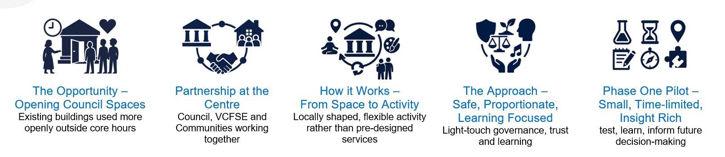

Please be advised this is not a competitive procurement process. Submitting an EOI does not guarantee participation – submissions will be considered based on their fit with the aims of the pilot, practicality and potential learning value.

Please find enclosed the Expression of Interest (EOI) form. Supporting documents, including the Information Pack and Potential Sites Information, are provided separately and set out further detail on the purpose of the pilot, what to expect during mobilisation and delivery, and the buildings available.

If you have any questions, require clarification or would like a brief discussion regarding this pilot, please get in touch with the Commissioning Team via email at awpicomm@lancashire.gov.uk by 5pm on Monday 22nd June 2026.

Completed EOIs should be returned to awpicomm@lancashire.gov.uk by 9am on Monday 29th June.

We would very much welcome your interest in this opportunity and look forward to receiving your completed expression of interest.

Yours sincerely,

Antony Bell-Thorn
Head of Commissioning – Strategy & Partnerships
Strategic Commissioning & Quality
Adults, Health and Wellbeing Directorate

1. Introduction

This Expression of Interest (EOI) form is to be completed by Voluntary, Community, Faith and Social Enterprise (VCFSE) organisations interested in participating in a Lancashire County Council pilot exploring the evening and weekend use of day centre buildings.

This EOI form is designed to support a proportionate and learning-focused process. Responses will help the Council understand suitability, practicality and the potential contribution to the aims of the pilot. To support your response, please refer to the accompanying documents, which provide further context on the purpose of the pilot, the potential sites and practical guidance to help you shape your submission.

2. About your Organisation

2.1 Please provide the required information about your organisation

Main Organisation Name
Legal Status | ☐Charity ☐CIO ☐CIC  ☐Unincorporated Group  ☐Other (please specify________________________)
Main Contact Name and Role
Email Address
Phone Number
Website or Social Media
(if available)

2.2 If applying in partnership
If you are applying as part of a partnership or collaborative approach, please identify the lead organisation (as set out above) and provide details of partner organisations below. The lead organisation will act as the main point of contact for this pilot.

Please add additional rows as needed to include all partner organisations.

Partner Organisation Name | Legal Status | Main Contact Name, Role and Email

3. Your Interest in the Pilot

3.1 Why are you interested in taking part?

Briefly explain what has attracted you to this pilot and how it aligns with your organisation's values or current work.
(maximum 200 words)

3.2 Who would your activities be for?
Please tick all that apply:

☐Adults who do not attend daytime services
☐Working-age adults
☐Unpaid carers
☐Older people
☐People at risk of loneliness or social isolation

☐Other (please describe)

3.3 What types of activities might you offer?

Please provide an indicative outline. This does not need to be fixed or fully developed.
(maximum 200 words)
(For example: social or friendship groups, shared meals, creative or cultural activities, peer support, interest-based sessions)

3.4 Relevant Experience (if applicable)

Briefly describe any experience you have of delivering community activities, particularly outside standard daytime hours or in shared or community buildings.
(maximum 200 words)

3.5 When would you expect to use the space?

☐Weekday Evenings ☐Weekends ☐a mixture of both

Please share indicative use times if known:

4. Approach and Values

4.1 Involving People and Communities

How would you involve people and communities in shaping and developing activities over time?
(maximum 200 words)

4.2 Creating a Welcoming and Inclusive Environment

Briefly describe how you would help create a welcoming, inclusive and non-clinical environment.
(maximum 150 words)

5. Practical Considerations

This section is intended to confirm that activities can be delivered safely. Evidence is not required at EOI stage.

5.1 Safeguarding
Please confirm:

☐We have a safeguarding policy appropriate to our activities
☐We understand safeguarding thresholds and escalation routes
☐We are working collaboratively with another organisation to ensure these requirements are met

5.2 Insurance
Please confirm:

☐We hold (or can obtain) appropriate public liability insurance
☐We can provide evidence if invited to participate
☐We are working collaboratively with another organisation to ensure these requirements are met

5.3 Health and Safety
Please confirm:

☐We have a nominated First Aider
☐The nominated First Aider has up-to-date training
☐We have capacity to safely access, open, and manage a building
☐We are working collaboratively with another organisation to ensure these requirements are met

5.4 Staffing and Volunteers
Activities would be delivered by:

☐Staff ☐Volunteers ☐A combination of both

Please provide a brief description to demonstrate basic organisational governance and accountability for the delivery of activities:
(maximum 150 words)

6. Learning and Participation

This pilot is focused on learning and reflection, rather than performance targets.

Please briefly outline how you would be willing to contribute to learning through this pilot.
(maximum 200 words)
(For example: sharing reflections, informal feedback, or short learning stories about what worked or what could be improved.)

7. Potential Pilot Sites

7.1 Location
Please indicate which site(s) you are interested in:

North
☐ Fylde District Adult Disability Service
☐ Lancaster and Morecambe District Adult Disability Service
☐ Vale View Day Centre
☐ Milbanke Day Centre

Central
☐ Fosterfield Day Centre
☐ Lady Elsie Finney House Day Centre
☐ Leyland Day Centre
☐ Preston District Adult Disability Service

East
☐ Woodhaven Day Centre
☐ Mearley Fold Day Centre
☐ Burnley and Pendle District Adult Disability Service

7.2 Site Preferences
If relevant, please note any preferences or constraints relating to the location, any accessibility requirements, facilities or space needs. Preferences will be considered where possible but cannot be guaranteed.

(maximum 150 words)

8. Final Declaration

By submitting this Expression of Interest, we confirm our understanding that:

- This opportunity involves free use of specified potential Council buildings only
- There is no funding, contract or service purchase associated with the pilot
- Participation is time-limited and subject to agreed conditions of use
- Assessment will be based on fit, safety and learning value, not competition
- Submitting an EOI does not guarantee inclusion with this pilot

Name
Role
Date:

