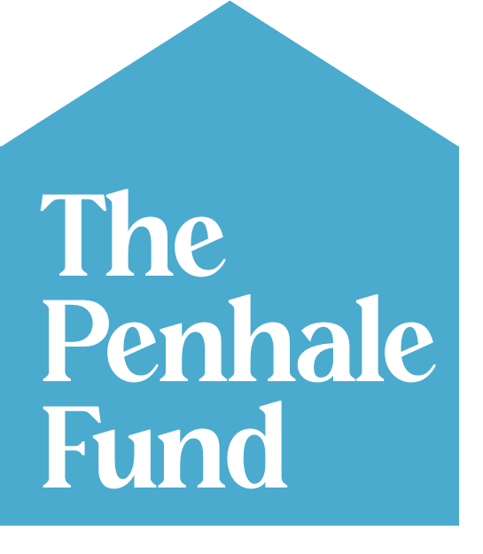
The Penhale Fund application form

The Penhale Fund holds money that exists to help charities and community organisations in the Morecambe and Heysham area to thrive.

We know that you are experts in what you do and that funding applications can take time. We want this form to be as simple and straightforward as possible. Please answer the questions below,and stick to the word limits.

We’ll consider applications every three months. If you want to send us pictures or video links, that’s fine! We can award any amount from £1 up to £3,000.

Our Questions

About you

What’s your name?

Please write down your contact details including phone number, an email address, and best correspondence address

About your organisation

What’s your group or organisation’s name?

Is your organisation over a year old?

If not, when was it founded, and why?

Is your organisation based in the LA3 or LA4 postcode?

Yes / No

If your postcode or your main operation is outside the Penhale Society’s funding area, can you confirm the activity you are applying to fund will take place in Morecambe and/or Heysham?

Yes / No

If you answered yes to the question above, when and where will it take place?

In a hundred words or less, please describe the work of your organisation

Please provide a link to your website if you have one

Please give us any other online links (e.g. social media, other relevant pages or videos you want to show us)

Why you require funding from us

In fifty words or less, what do you need money for?

What is the total you wish to apply for?

What exactly will you do with it? (300 words max, please include a brief budget breakdown with anticipated costs)
Please feel free to add any links to quotes you have received for your costings or attach any other documents you feel are relevant

What is the proposed start and end date of your project?

If your project will be delivered in partnership with other organisations, can you confirm that all partners are onboard with this application and are ready to proceed on the proposed start date?

If we award you a grant, how will the money help your organisation overall? What’s the bigger picture? (300 words max)

Lastly, how did you hear about The Penhale Fund?

