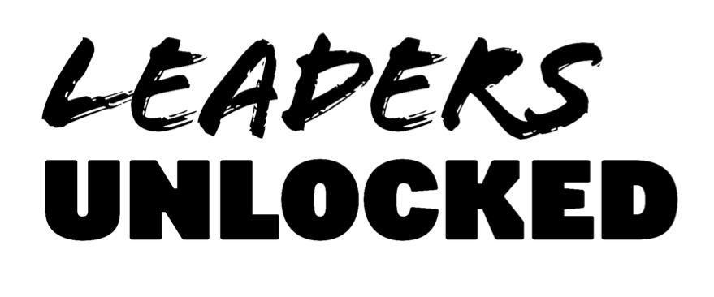
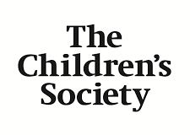

Young Advisors for the Good Childhood Report: About this opportunity

Please read this guidance carefully before filling in your application form.

- What is this opportunity?
Young Advisors for the Good Childhood Report is an exciting new project with The Children’s Society, which will enable young people to explore the latest trends in children’s wellbeing and contribute to a major national report.

Young Advisors will collaborate with The Children’s Society over an 8-month period to inform the annual Good Childhood Report in 2026. We are looking to recruit a diverse group of 10-12 young people aged 13-17 years from across England for this opportunity.

The project aims to:
- Explore the key trends in children’s wellbeing and discuss the factors behind these trends.
- Explore and discuss the key findings from the 2025 report that are relevant to the theme of the Good Childhood Report 2026
- Support Young Advisors to have peer-to-peer conversations in their education settings and personal networks to gather the views of other young people.
- Work with Young Advisors to develop solutions to address the issues identified by the project.
- Enable Young Advisors to collaborate with The Children’s Society to contribute to their Good Childhood Report in 2026.

The project is a partnership between The Children’s Society and Leaders Unlocked, a social enterprise supporting young people to influence the decisions that affect them in society.

- Who can apply to be a Young Advisor?
We are looking for up to 10-12 young people aged 13-17 years who are motivated to explore the latest trends in children’s wellbeing. This opportunity is open to young people living anywhere in England.
We are very keen to ensure that the team is made up of a diverse group of young people with a wide range of experiences. We are especially keen to hear from young people who have any of the following experiences and backgrounds:

- Experience of financial hardship
- Identifying as LGBTQ+ and/or non-binary
- Being from Black or racialised background
- Living in supported accommodation, children’s homes, secure units, or any other supported living

It will not be a requirement for young people to share their own experiences if they don’t want to, but we will foster an accepting and supportive culture to enable people to share experiences if they wish to.

- If I join, what will I have to do?
The project will run over an 8-month period from March 2026 to October 2026. Over this time, Young Advisors will take part in the following activities:

- Co-design workshops: Over the course of the project, we will be holding five workshops (3 online, 2 in-person) with the Young Advisors. At these sessions you will have the opportunity to meet and work with colleagues from The Children’s Society. You will be able to discuss the latest trends in children’s wellbeing and explore the factors that lie behind the trends.
- Receive training in facilitation and peer research skills: We will hold one of the workshops with a specific focus on building key skills for facilitation and research - including research design, interview and focus groups techniques, active listening, ethics and safeguarding with an opportunity to put these into practice during the session. This session will be held in-person at The Children’s Society’s office in London.
- Help to gather the views of other young people: You will be supported to carry out peer-to-peer conversations with young people in your education settings and/or young people from Leaders Unlocked or The Children’s Society’s networks. The aim of these conversations will be to capture other young people’s views on the theme of focus for the Good Childhood Report and the associated trends in children’s wellbeing, and what needs to change. We would aim for each Young Advisor to gather the views of approximately 10 other young people, in a way that’s appropriate to each person’s situation.
- Collaborate with each other and The Children’s Society to develop solutions: In June 2026, we will bring the Young Advisors together at The Children’s Society offices in London, to discuss the findings of the project and to develop ideas for solutions. The discussions at this event will directly feed into the Good Childhood Report in 2026. *For any Young Advisors who are unable to attend in-person for any reason, we will hold a separate call to ensure they have an opportunity to input their ideas.

- Involvement in the creation of the Good Childhood Report 2026: Over the summer, we will support a core group of the Young Advisors to collaborate with colleagues from The Children’s Society to contribute to the analysis of findings and development of the Good Childhood Report 2026.

- How much of my time will be required?
We anticipate that each Young Advisor will spend approximately 18-20 hours on the project’s activities. These hours will be spread out across the duration of the project. For those who may want to get involved in the writing process for the Good Childhood Report, there will be an optional opportunity to volunteer some additional hours as co-authors of the report. Please note: You will not be required to miss school or college to take part in project activities.

- What will I get from being part of the project?
- Gain valuable knowledge and skills: You will have the opportunity to develop valuable knowledge and transferable skills, including leadership skills, research skills and public speaking. You will also build confidence in working with peers and adult professionals. You will be able to use the experience for your CV, when applying for jobs or to Further or Higher Education.
- Collaborate with professionals and other young people: You will expand your network and collaborate with a range of professionals from The Children’s Society and other young people across the country with a shared interest in children’s wellbeing.
- Be a part of a major national report: You’ll help to develop content for the Good Childhood Report, and to get involved in aspects of the report’s launch, which may include events and producing creative media content.
- Receive a thank you payment for your contribution: You will receive a total of £180 for your contributions to the project. This will be split into 3 payments of £60 across the project to ensure you are being compensated for your contributions throughout. This payment will be either in cash or in voucher form. For under-16s, the payment will be made in an eVoucher form (which can be redeemed in a wide range of brands / stores). Over-16s will be able to choose between bank transfer or an eVoucher.

- How do I apply?
Please fill in the enclosed application form and email it to Folade@leaders-unlocked.org by 23rd February 2026.

- What happens next?
Once we receive your application, we will then carry out brief telephone interviews with a shortlist of applicants. All applicants will be informed by the week after the application deadline whether they have been selected for interview.

Remember: please email your completed application form to Folade@leaders-unlocked.org by 23rd February 2026.

