West End Community Consultation Questionnaire
  - Stanleys Community Centre and More Music would like to know what you think about the West End. Please take a few moments to answer the following questions. All responses are confidential.
Connection to the West End
What is your connection to the West End? (Please tick all that apply)
Live ☐ Work ☐ Access services ☐ Visitor ☐
Other please state: _____________________________________________________

For how long have you had this connection? _____________________________________

Community and Pride
What makes you feel part of the West End community? ______________________________
__________________________________________________________________________________________________________________________________
What aspects of the West End do you feel most pride in? _____________________________
__________________________________________________________________________________________________________________________________

Concerns and Aspirations
What is the thing that you are least happy about in the West End? _______________________
__________________________________________________________________________________________________________________________________
What would you love to see in the West End? ____________________________________
__________________________________________________________________________________________________________________________________
How would you make this happen? __________________________________________
__________________________________________________________________________________________________________________________________

Further Involvement
Are you happy to be contacted for further conversations about this? Yes ☐ No ☐

We’ll be offering vouchers to people who participate further

Demographic Information
Age (please tick): 5–11 ☐ 12–18 ☐ 19–30 ☐ 31–45 ☐ 46–60 ☐ 61–74 ☐ 75+ ☐
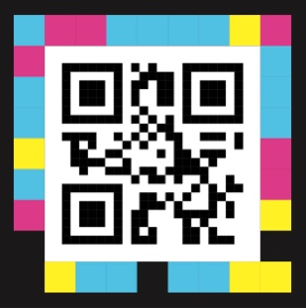
Postcode: ____________________________________________________

Name: ______________________________________________________

Email: ______________________________________________________

Phone: ______________________________________________________ Thank you!

