

Lancashire Young Carers
Do you look after someone in your family who is unwell?
Would you like someone to talk to about it?
If you are 5-11 and answered yes to any of the above, have a look inside…

Do you look after someone in your family who is unwell?
How do you cope with caring for someone in your family?
Do you need any support for yourself?
If you are 11-18 and answered yes to any of the above, have a look inside…

Lancashire Young Carers

Being a young carer isn’t just about looking after a family member because of a physical disability; illnesses can be hidden too, for example poor mental health or drug/alcohol misuse.
This is what two of our young carers have said about their caring roles:

Ava - I’m a young carer because my mum has a physical disability, and she uses a wheelchair. I clean the house daily and support my mum to get around; I also support her with the weekly shopping. Sometimes I worry about her when I can’t be with her.

Isaac - I’m a young carer because I care for my two brothers and mum. My brothers have behavioural issues, and my mum has anxiety. I support mum emotionally, help with daily tasks and looking after my brothers. I take on lots of responsibility at home.

Who is a young carer?

A young carer (18 and under) looks after a parent, guardian or sibling that is ill or disabled.
What might a young carer do?

- Help with shopping
- Help with giving medicine
- Housework & cooking
- Make sure their cared for person is alright
- Help their cared for person get in and out of bed
- Help with money (like bills and benefits)
- Help their cared for person get washed and dressed
- Help to look after little brothers and/or sisters
- Get help in an emergency

Who is a young carer?
Hi, my name is Henry and I’m going to answer some questions about young carers….

Your Voice & Influence

Your voice is at the heart of our service. Our support workers are there to listen and act upon what you say. The support provided will be guided by your needs to make things easier for you in your caring role.


Amelia and Katies’ story
There are two young carers called Katie and Amelia, they both have to care for their mums because they are disabled, so their mums decided to check out the local ‘Young Carers Service'.
Katie and Amelia now have a support worker from Barnardo’s, who they meet with and can talk to about how they feel and the help they need.
They get help with how they feel, and their support workers have spoken to school so they understand about young carers and can make sure that they are okay. They have also spoken to other adults from different places that have helped the whole family.

Did you know Amelia and Katie wrote this story themselves?! Now they are much happier as more people understand their caring roles.

There are many ways you can get involved and have your voice heard:
This booklet is influenced by what young carers want you to know!
What’s happening for Jack as a young carer?


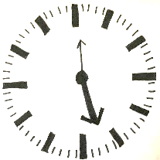
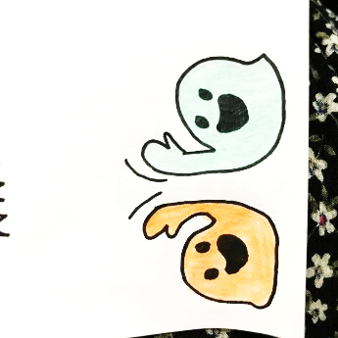
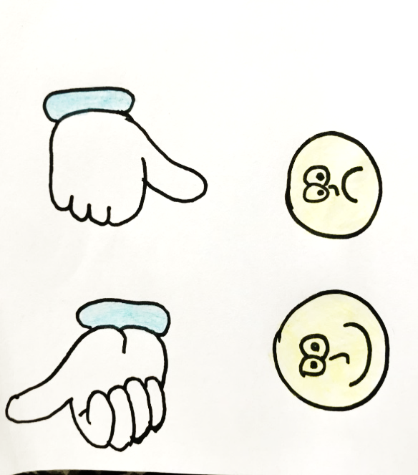
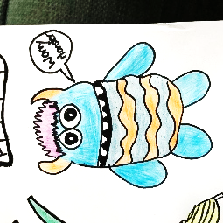
c
What’s happening for Chloe as a young carer?

“I take days off school to look after my brother when my mum is ill. This gets me into trouble at school, so I told a teacher about what was happening, and she referred me to Lancashire Young Carers.”

“I worry that if I tell the truth about what is going on at home, that it might get my mum in trouble.”

“I don’t really understand my mum’s illness or how to help her which makes me feel sad, frustrated and confused.”

“I feel alone, and my friends just don’t understand what it’s like for me.”

Are you ready to listen to 9-year-old Jack’s story? Let’s read on to see what he said…
“I don’t think anyone knows what it’s like for me, I wish I could talk to someone about what I do at home and how I feel.”
“I spend most of my time helping my mum, and sometimes it’s hard and I get tired. I wish someone could help.”
“No one knows I’m a young carer, it feels really lonely.”
“I get really worried about my mum when I’m at school and she’s at home.”

How have things changed for Chloe as a young carer?

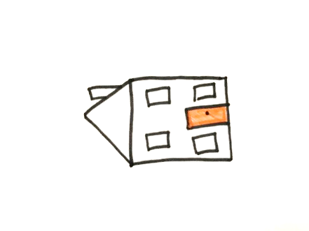
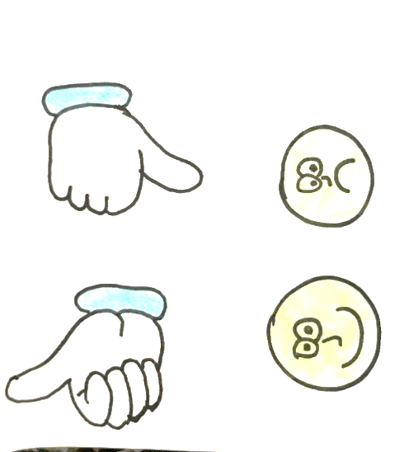
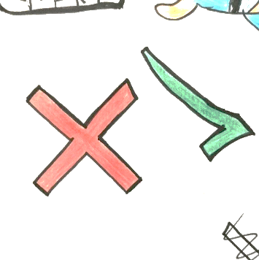
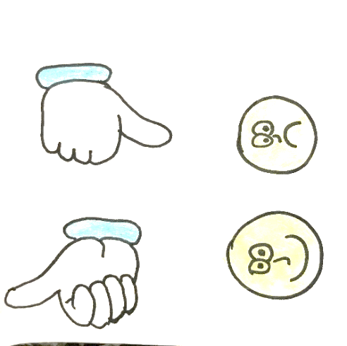
How have things changed for Jack as a young carer?

Let’s hear how Barnardo’s Lancashire Young Carers helped Jack…

“I have also become a member of the Young Carers Connect Forum (YCC) and enjoy speaking up and raising awareness about young carers and meeting other young carers who get me.”

“My mum gets more help, so things are a bit easier at home and school have had a YCARE assembly and training, so everyone understands what it’s like for me at home as a young carer. This has made school a much more supportive place to be.”
“I have my own support worker who listens to me and helps me with my questions. I feel happier having someone to talk to”

“I had an assessment with Barnardo’s; they were lovely and told me I was a young carer. We made a support plan together.”
“There is more help for mum at home, so it’s easier for me and I get some more free time to do things like drawing, watching TV and playing out.”
“I have heard about young carers and met other young carers so now I know I’m not alone.”
“My support worker listens to me and I can talk to them about what I do at home and how I feel.”
“My teachers now know I am a young carer so they understand if I am feeling worried in school, and I can talk to someone about it. I also have a YCARE passport.”

What Lancashire Young Carers can offer you….

Scan to find our referral form, connect with us on socials & browse our helpful information and resources.
.
The Young Carers Connect Forum (YCC) to influence services for other young carers.
Help to access other services.
Focused group work with other young carers on specific issues important to you.
An assessment which helps you and your family think about things that would make a difference.
A chance to have your say about the support you receive, want, and need on issues that are important to you and your family.
1 to 1 support to reduce the negative impact of your caring role.
Tips and techniques for your wellbeing.
Information about the illness or disability of the person you care for.

Support with change, such as changing school or moving to adult services.

Information on local activities to meet other people.
Help for your whole family.
Opportunities to meet other young carers and have a VOICE!
Social media updates on upcoming events and opportunities.

How to contact us:
If you think you are a young carer and would like to know more, please contact us or ask someone else to contact us for you on: Phone: 01772 641002 or Email: lancashireyoungcarers@barnardos.org.uk

