Have you completed your cancer treatment?

Are you struggling to create a ‘new normal’ life?



Help Overcoming Problems Effectively (HOPE) course
The ‘HOPE Course’ helps people manage the day-to-day impact cancer has on their lives and rediscover their strengths after treatment ends.
Residents of North Lancashire and South Cumbria living with and beyond cancer can benefit from this free course facilitated by the Macmillan Cancer Information and Support Service (MCISS) Team at University Hospitals Morecambe Bay NHS Foundation Trust.
Designed for people who have had cancer, regardless of the type, who may be finding it difficult to cope after completing their treatment.

Delivered by trained professionals, HOPE is an interactive, face-to-face, 2-day course, covering topics to help participants rediscover their strengths and make the most of the positive things in life, whilst addressing concerns in relation to fear of cancer returning.

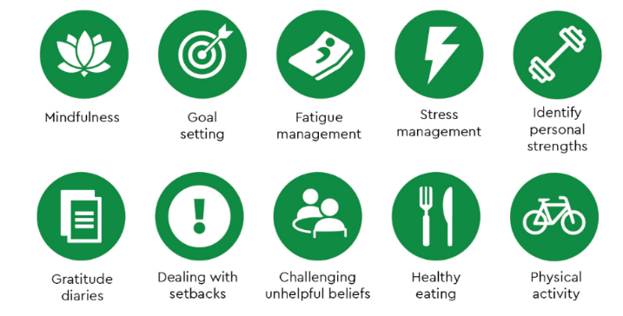

The course is run with a small group of up to 10 mixed participants.

Next course : Lancaster (9th March and 16th March 2026)
Participants are required to attend both sessions and booking is essential.

To register your interest in attending or to make a booking please contact the MCISS team who will be happy to support you.

Telephone: 01524 519578 / 07972639424 Email: macmillan.info@mbht.nhs.uk

