

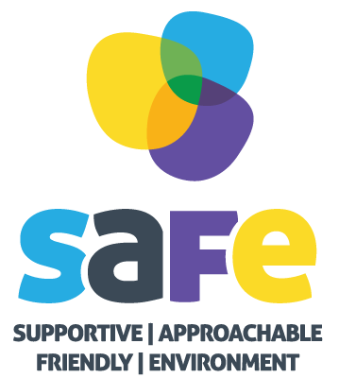
Referral Criteria – SAFE Prop Up Project
Please answer the questions below following this, complete the referral form and return to the SAFE team.
Is the young person aged between 13-19? | Yes/No
Does the young person live in the Lancaster City Council district? | Yes/No
Is the young person experiencing struggles with their mental health, which is affecting their daily life and ability to socialise? | Yes/No  Comments:
Is the young person engaging with other organisations? | Yes/No  Comments:
Referral Form SAFE: Prop Up Project

Date of referral:

NAME (Young Person):
AGE & DATE OF BIRTH:
ADDRESS:
METHOD OF CONTACT YOUNG PERSON Email/Telephone:
PARENT/GUARDIAN/NEXT OF KIN NAME:
PARENT/GUARDIAN/NEXT OF KIN CONTACT NUMBER:
DETAILS OF GP SUGERY YOUNG PEOPLE IS REGISTERED WITH:

Referring School/Organisation:
Does this person consider themselves to have a disability?
Yes o No o Prefer not to say o
Reasons for Referral:

Which group is this referral for (please tick): Young Adult group 20-25yrs o Morecambe 13-19yrs o Carnforth 13-19yrs o Lancaster 13-19yrs o
Relevant Medical History: (Please state any physical & mental health diagnoses here)

Any Other Relevant Information (including any other agencies/services involved, preferred place to be seen, environmental considerations and relevant child health problems):


Health and Safety (Must be Completed)

Violence & Aggression Risk: Yes o No o
Please outline:

Action to be taken:

Safeguarding Risk: Yes o No o
Please outline:

Action to be taken:

If you are a professional completing this form, please confirm the parent/guardian and young person are aware of and have given consent for this referral to be made by ticking this box. o

Referral Agency: | Referrers Name:
Address: | Tel Number:

I consent for SAFE to store and process this information for purposes as outlined in our privacy notice & data protection policy:

Signed:
Date: ___________________________________________

Once this referral is received by the SAFE team, it will be triaged and if appropriate, a SAFE team member will follow up with the parent/guardian and the individual.

Office Use Only
Date Referral was contacted:
Appropriate for which group:

