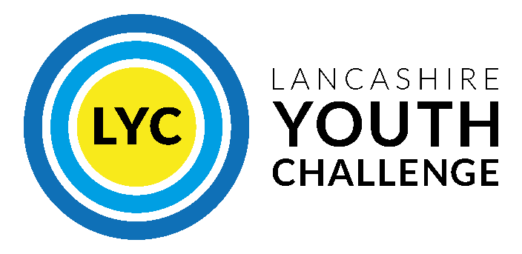
Job Opportunity: Programme Facilitator
Location: Lancaster, Preston, and Remote Working
Salary: £25,974 per annum (£13.50/hour) + 3% pension
Hours: 37 per week (including evenings/weekends)
Contract: Permanent
Deadline: Friday 20th June 2025, 5pm
Interview Date: Friday 27th June 2025
Lancashire Youth Challenge (LYC) is an award-winning charity that nurtures, supports, and empowers young people aged 11-21 years to discover their potential, cultivate resilience, and build a foundation for lifelong success. We’re looking for an enthusiastic and experienced Programme Facilitator to join our dynamic team.
You’ll play a vital role in designing and delivering inspiring, inclusive workshops across our three core programmes: Time to Breathe, RESTORE, and Rise to the Challenge. Working in schools and community settings across Lancaster and Preston.
Key responsibilities include:
- Planning and leading engaging workshops and residentials
- Building relationships with young people, families, and partner organisations
- Supporting monitoring, evaluation, and impact reporting
- Ensuring safeguarding and accessibility are prioritised throughout
We’re seeking someone with experience of working with young people in educational or youth work settings, who is passionate, adaptable, trauma-informed, and committed to promoting inclusion and equity.
Interested? Email your CV and cover letter (max 3 pages) to: guy.christiansen@lancashireyouthchallenge.co.uk
For more details, visit: https://lancashireyouthchallenge.co.uk/work-with-us/
We value diversity and especially welcome applications from underrepresented groups.
This post is subject to an enhanced DBS check.

