***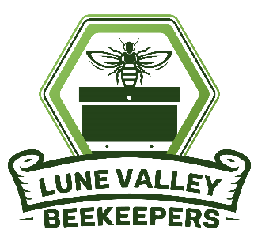*LUNE VALLEY BEEKEEPERS**

**OPEN DAY**

**Saturday, 12th July**

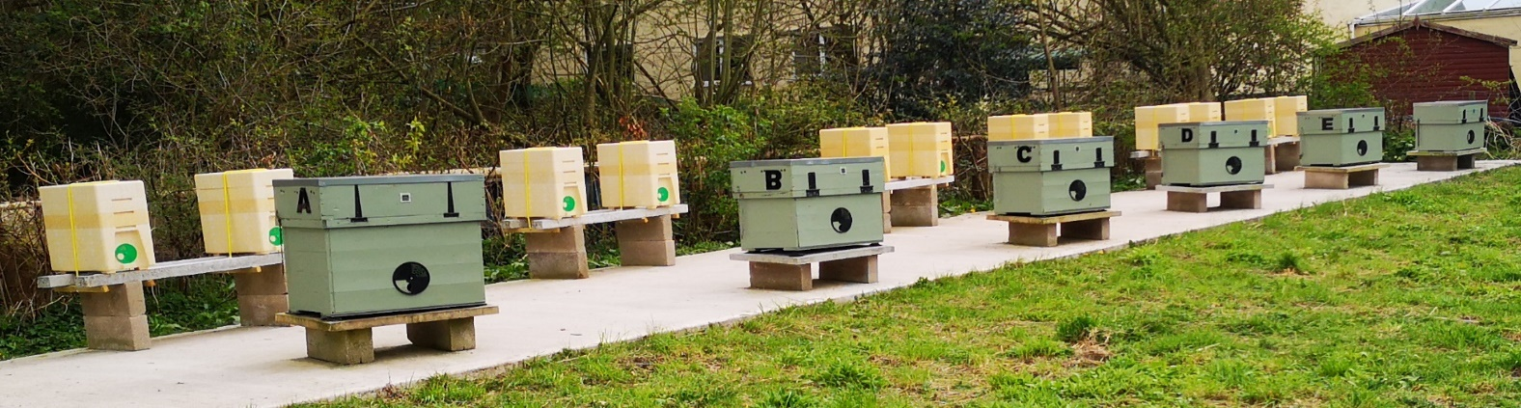**11-00am to 4-00pm**

**See honey bees in an observation hive**

**See inside a Lune Valley Long Hive**

**Observe our training and breeding apiaries**

**Information about honey bees and pollination**

**Craft stalls, Beeswax candles and polishes**

**Local Honey, Plants for Bees**

**Tea, coffee and cakes, Barbecue**

**Free admission - Free Parking**

**The Apiary, Nazareth House**

**Ashton Road, Lancaster LA1 5AQ**

[**www.lunevalleybeekeepers.co.uk**](http://www.lunevalleybeekeepers.co.uk)