Stanleys Community Centre is Looking for Volunteer Trustees
We are Stanleys Community Centre, a registered charity (number 1183140), set up by the community in the West End of Morecambe, Lancashire in 2019, to meet the needs of local people.
Our 5 Trustees, and team of 9 staff and 36 volunteers are members of the community with lived experience of some of the issues that our community face. Our vision is that all residents living in Morecambe enjoy a high quality of life, can achieve their economic, social and educational goals, and feel part of a strong, prosperous and caring local community.
We support over 2000 local people from birth up each year through a varied and busy programme of youth, health and wellbeing and community programmes.
“The support I received at Stanleys really worked. Its world because it’s so clear they genuinely care about me, and everyone in the community”
- Gemma, Member of Stanleys Fibromyalgia Support Group
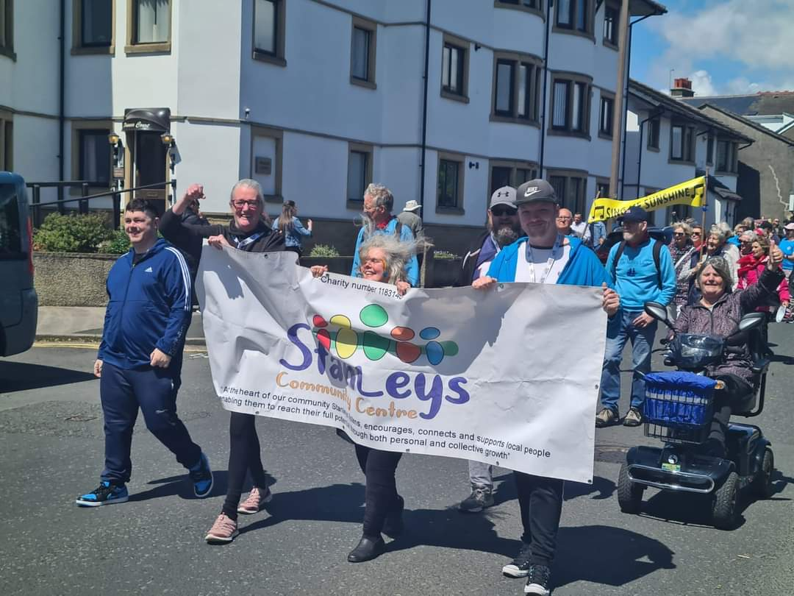

We are now looking to recruit new Trustees to our board. Trustees are volunteers who help to set the direction of a charity and to ensure that we meet the needs of local people. You would be joining Stanleys at an exciting time. We have experienced four years of growth and are preparing to take over ownership of the building we currently rent to provide a sustainable community hub.
Who we are looking for
We have just completed an audit of our current board’s skills and experience. To ensure that we have people with the right skills and experience to help support Stanleys Community Centre’s exciting next steps, we are looking for people with at least one of the following skills, knowledge and experience to join our board.
- Financial Management and Accounting because Stanleys has increased our income by 50% per year for three consecutive years we are now looking for strategic financial experience to support us to ensure we have robust financial processes in place and to support us to recruit our first dedicated finance officer.
- Charity governance, strategy, and legal experience. The building is now in community ownership, and we are busy getting ready for some major renovation work. This is an exciting opportunity for the trustees to make a real difference to the future of our charity.

We already have some expertise in these areas on the board, but our charity would benefit from further and varied expertise in these two areas. We hope to recruit two new trustees early February 2025 and will also be looking for a young person aged 18-25 to join our board in April 2025.
You don’t need to have been a charity trustee before; we will provide a supportive induction.
We would like to ensure that our board remains diverse and includes a mix of professional skills and lived experience and therefore would particularly like to hear from women, people of colour, younger people, people with disabilities, those who are recognised as neuro-divergent, working-class or from other under-represented groups. If you can bring a new perspective, we would love to hear from you!
Time commitment
We usually meet monthly for up to two hours online, (currently weekdays, early evening). We are an active board and are looking for people who can be enthusiastic and committed to supporting our strategic development through providing support and guidance to our Centre Manager in between meetings.
The estimated time commitment is on average around 4 hours per month, although some months will be more and others less.
The roles are voluntary, and so unpaid, but we will pay reasonable travel and meal expenses.

What’s in it for you?
- Stanleys is a special place, people from all walks of life find support, friendship and community in our building - often people come to us when they are in a desperate place, in need of access to food, warm spaces or mental health support and quickly feel supported and empowered to help their neighbours and become active members of the community. You will be able to see the impact you are making on peoples’ lives immediately.
- You can use your existing skills, knowledge and networks to support some of the most vulnerable people in Morecambe, whilst gaining and developing new skills.
- You would join a great committed and varied team of trustees all striving to grow Stanleys’ charitable impact.
- You will gain valuable strategic experience in making critical decisions that will support the growth and development of a charity.
- You will find being a Trustee is incredibly rewarding and a fantastic way to give back.
How to apply
You can find out more about our work on our website at www.stanleyscommunitycentre.co.uk
To apply, please send your CV plus a short cover letter telling us why you are interested in applying and what you would bring to Stanleys Community Centre, to Robyn Thomas, Centre Manager, stanleyscommunitycentre@gmail.com by Monday the 6th of January 2025
If you are thinking of applying but would like to find out more first, please send us an email to arrange a chat.
We expect to hold informal interviews early February 2025 and trustees will be appointed later that month.

