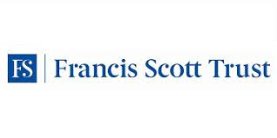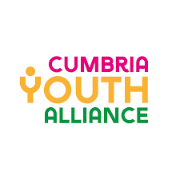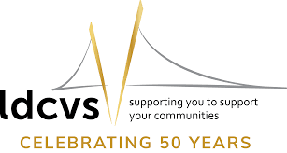

Break the Mould Evaluator
Briefing Document

Introduction
To help us document the impact of a pilot initiative, Cumbria Youth Alliance (CYA) and Lancaster District CVS (LDCVS) are seeking an experienced interviewer and evaluator to work with a small group of young people and staff from the Break the Mould project.
To gather the information, CYA and LDCVS will support the professional to set up a series of informal meetings with young people and staff from the project. These meetings will form the basis of a short report that can be used with the project’s funder, partners, stakeholders, and other interested parties.

About Break the Mould
In 2023, the Francis Scott Trust celebrated 60 years of supporting work with young people. To mark this milestone year, they asked that a group of local young people to distribute funds on the Trust’s behalf. Young people from across the Trust’s beneficiary area of Cumbria and Lancaster District were invited to design a grants programme and distribute £60,000 throughout 2023 that would benefit other local young people via their organised groups to support activities that are important to them.
Between June and December 2023, a group of 14 young people came together to design the framework for a new grant scheme. Launching on the 29th of September 2023, the scheme was available to constituted organisations that work directly with young people aged 16-24 living and working in Lancaster and Cumbria.
Whilst the programme was designed to celebrate the 60th anniversary of the Trust, it was also a learning exercise for us, to hear first-hand what is important to young people, and to inform and influence future frameworks for adopting youth voice in both grant making systems and strategy. Working collaboratively as infrastructure organisations was an amazing opportunity for us to bring the programme to life, acting as coordinators and facilitators of the programme while recognising that we were all at the beginning of a journey in engaging young people in this way.

About the Role
Working closely with the two organisations, the selected professional will develop and deliver a framework for gathering information about both organisations and young people’s time on the project. Using robust ethical methodologies, the professional will sensitively guide everyone on a journey of self-discovery, helping them to connect their experiences on the project, to learning and skills development.
This will allow us to determine the impact the project has had in empowering young people to make a difference in their lives and in their local communities.
We are looking for someone that knows how to make meaningful connections with people in a short space of time and deliver a deeper level of questioning to reveal the rich tapestry of experiences, good and bad, helping to write the story of their journey on the project.

Project Outputs
At the end of the commission, we would expect to see a digital report on findings.

Specification
Essential
- At least five years of experience working with, by and for children and young people.
- Proven experience of developing and leading on the evaluation of charitable projects.
- Demonstrable understanding of ethical practices when interviewing individuals.
- A calm, professional and welcoming demeanour, and ability to make meaningful connections with people in a short space of time.
- A commitment to equity of access and opportunity for all.
Desirable
- Experience of managing and delivering multi-year charitable projects with robust evaluation frameworks.
- An understanding of developing/ administering grant schemes.

The offer
For this commission we are offering £1000 to cover all planning, delivery and report writing, and £100 contribution towards travel expenses.

Next steps
If you are interested in this commission, please send us an up-to-date CV (with at least one reference) and a one-page cover letter outlining how your experiences complement the person specification.
The deadline for this will be Thursday 15th February 2024. Online interviews will take place on the morning of Monday the 26th of February 2024. If you will struggle to make this interview date, please let us know.
If you would like an informal chat about the commission, you can contact Catherine Westwell at Lancaster District CVS on 01524 555900 or by emailing catherinewestwell@lancastercvs.org.uk Further information on the Break the Mould project can be found on our website, https://lancastercvs.org.uk/break-the-mould/

