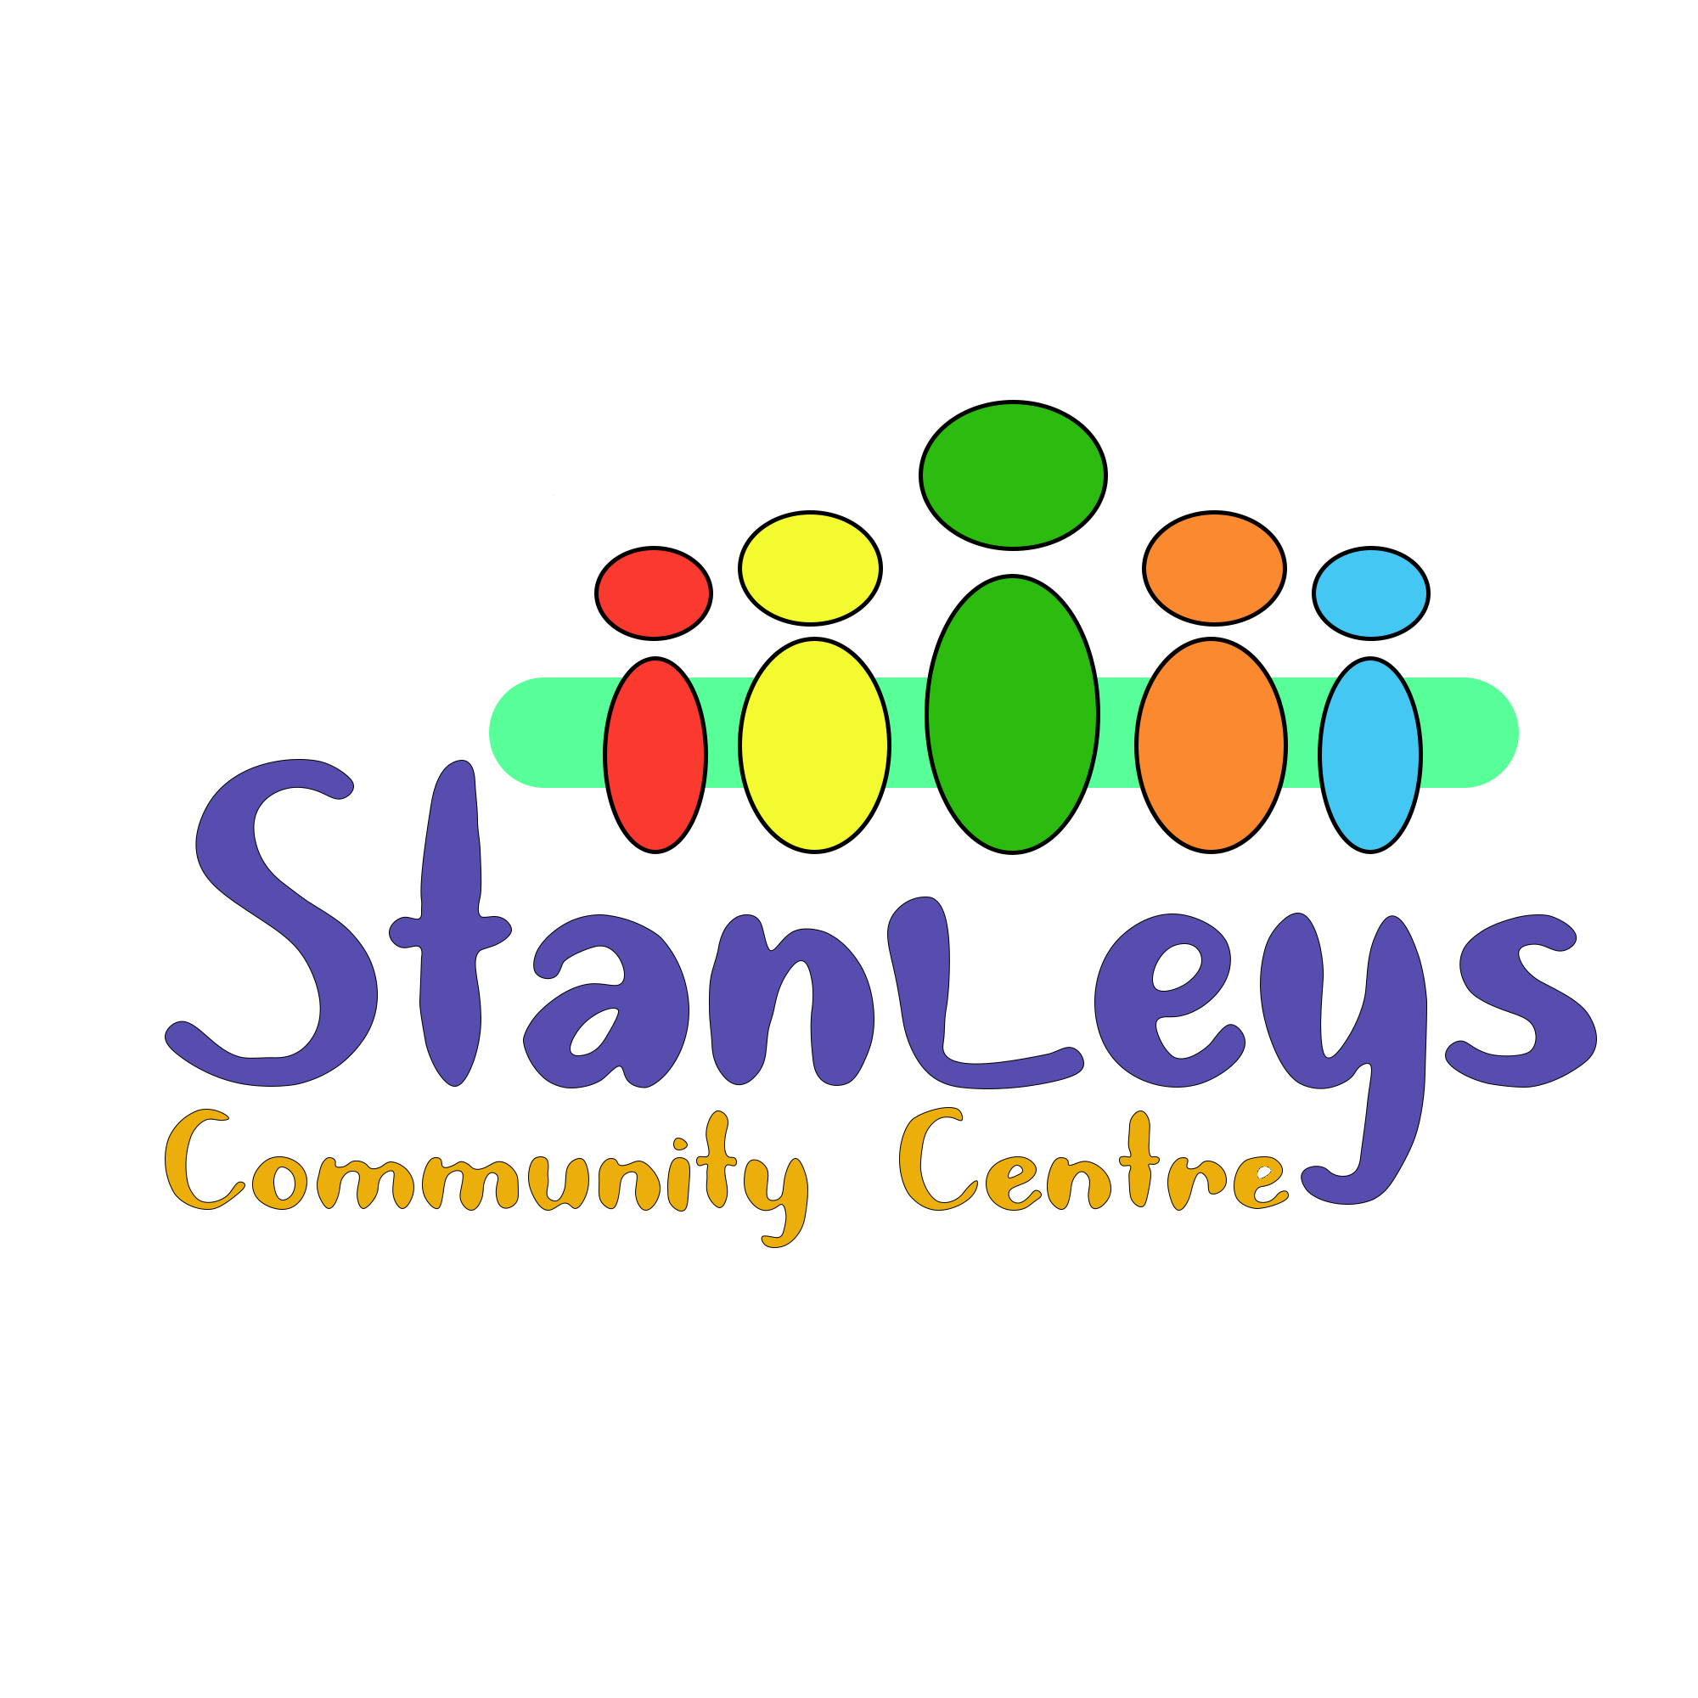Charity number 1183140
Stanleyscommunitycentre@gmail.com 07775874413 or 01524410076
WE ARE PLEASED TO ANNOUNCE
We are running the first Young Health Champions course at Stanleys, across 2 weekends the 3rd and the 4th of June and the 24th and 25th of June from 10am to 4pm. Transport to and from Stanleys are provided, as well as lunch and refreshments. There are only 8 places available so please book by phoning Robyn on 07775874413.
Young Health Champions
The Level 2 Award for Young Health Champions (YHC) is a qualification for young people between the ages of 14-24, with an interest in health and wellbeing who want to make their voice heard around issues that affect them and their peers, while also providing support to develop healthier lifestyles at school, college or in the workplace.
Who is the qualification for?
- Young people in schools, community settings, FE or HE who are interested in health and sign- posting health services to their peers.
- Year 9*-13
- Sixth form students
*Young people can achieve the qualification in Year 8 ready to take on the role in Year 9
The YHC Award gives young people the platform to:
- Increase knowledge about the risks to physical, mental, and social health, ranging from social media to substance misuse.
- Develop a better understanding of services and facilities available in their local community to support health improvement.
- Engage with their peers to provide support and guidance needed to develop healthy behaviours
- Lead a health promotion campaign on an issue that really matters to young people in their local area.
Why get involved in the Young Health Champions qualification?
For young people
• Young people are more likely to listen and approach peers for information
• Understand the benefits of a healthy lifestyle and learn the skills to make healthier choices
• Develop skills for the workplace
• Greater knowledge of the risks of unhealthy behaviours
• Linked to the key local and national support services
• Development for CV’s (for YHCs)
For the setting
• Improves health and wellbeing of students and staff • Increases health literacy
• Can be used to convey urgent health messages
• Supports PSHE messages
• Improves links between young people’s services

