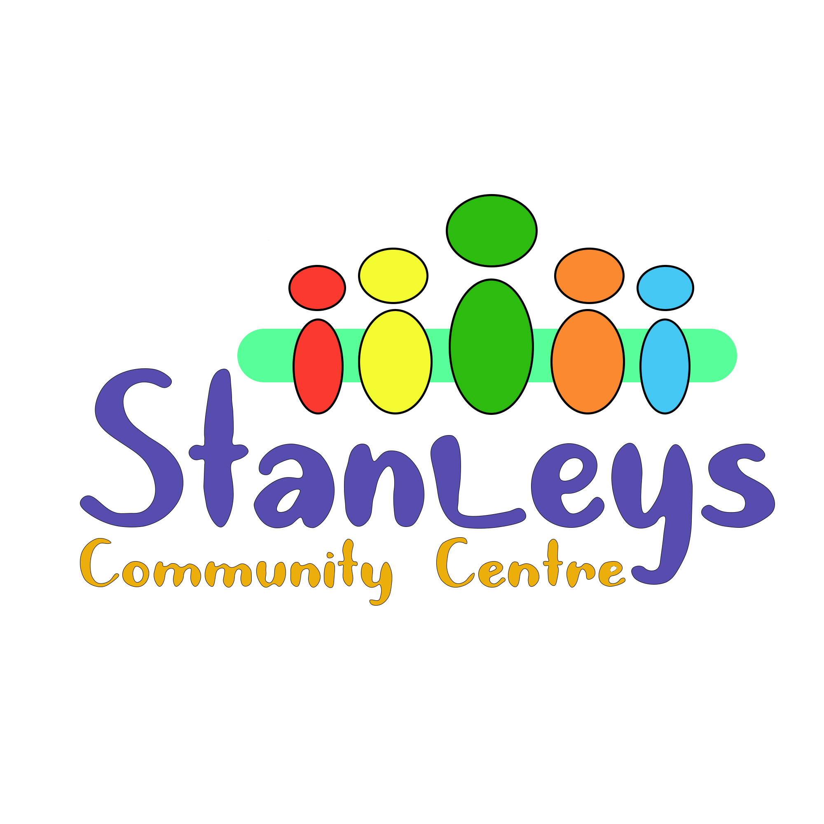

Stanleys Community Centre 79-83 Stanley Road Morecambe LA31UT

[www.stanleyscommunitycentre.co.uk](http://www.stanleyscommunitycentre.co.uk) 01524410076 or 07775874413

**Stanleys is pleased to announce that we have a new exciting opportunity to join our team**

**We are looking to employ an Operations Manager. If you are passionate about people and want to make a difference in our community please apply by writing a cover letter and attach your C.V. The closing date is 12pm on Friday the 23rd of June**

**Job Purpose:**

Stanleys Community Centre is a registered charity which runs a community centre.

Since achieving charitable status, Stanleys has seen incredible growth.

Stanleys is now a thriving hub within the West End, providing sessions designed to improve the Health and Wellbeing of its community, whilst achieving the 5 ways to wellbeing.

Stanleys employs 10 staff and has over 27 volunteers.

Stanleys has several key stakeholders including both statutory services and 3rd sector organisations.

Stanleys is very well supported by its ever-growing community.

The charity is in the process of purchasing the building from which it operates, this job role provides an exciting opportunity to really shape the future of the charity.

**Job Description**

**Salary:**  £30,000

**Holiday Entitlement**: 28 days per year

**Hours of work**: 35 hours per week usually Monday to Friday 9am to 3pm (occasionally you

will be required to work out of these hours and weekends).

**Pension Scheme**: Smart Pension

**Place of work**: Stanleys Community Centre (you will be required to attend relevant meeting

in and around the Lancaster District).

**Contract Duration**: Permanent (currently secured funding for 5 years)

**Responsible to**: Charity Director and Trustees

**Legal Employer**: Stanleys Community Centre

**Key Responsibilities of this role:**

To manage staff and volunteers and explore development opportunities.

Identify gaps and develop opportunities for Stanleys in alignment with Stanleys existing plan.

To oversee and become the organisational link between Stanleys and any free-lance consultants or others working within Stanleys.

Attend and participate and promote Stanleys in any meetings (relevant to this role).

Provide written and verbal reports to the Director, Trustees, Stakeholders and Funders

Consult and engage with relevant communities and partners to ensure co-development of solutions that appropriately meet the needs of our target audiences.

Implement improvements to operations identified by the Director and Trustees.

Maintain knowledge and understanding of current legislations governing best practice, including GDPR and Safeguarding.

Ensure compliance of policies and procedures set by The Charity Commission.

Systematically evaluate all elements of service delivery by consulting with service users and stakeholders.

**HR Responsibilities**

As Operations Manager you will have responsibility for;

* Maintenance of records including all DBS are in place and up to date.
* Retention and development of staff and volunteers.
* Health and safety of both staff and volunteers and compliance of relevant legislation.

**Administration**

As Operations Manager you will have responsibility for;

* Secure storage of hard copy and digital information.
* Managing access to information on a need-to-know basis.
* Implementation and back up of, monitoring and data.

**Essential skills for this role**

* Experience of working or volunteering in the Charity sector.
* Experience managing people (staff and volunteers).
* Skilled in the collation of data and impact of services for service users, to provide as evidence for grant applications, end of grant reports and local authority grant impact reports.
* Confident communicator with excellent standard of both written and verbal skills
* Proficiency using MS Office applications particularly in Outlook, Teams, Word, and Excel
* Understanding of working with people from all backgrounds and the ability to treat them with unconditional positive regard.

**Desirable Skills and Experience**

* Full Driving Licence.
* Professional qualification in relevant field e.g. Youth and Community degree.
* Understanding of Co-production of services using an asset-based approach.
* Experience in policy writing.
* Experience of business planning.
* Have a flexible approach to work and be receptive to new ideas and their implementation.

For further information about this role please contact Robyn Thomas on 07775874413

Or stanleyscommunitycentre@gmail.com