The University Hospitals of Morecambe Bay NHS Foundation Trust

Macmillan Information and Support Service.

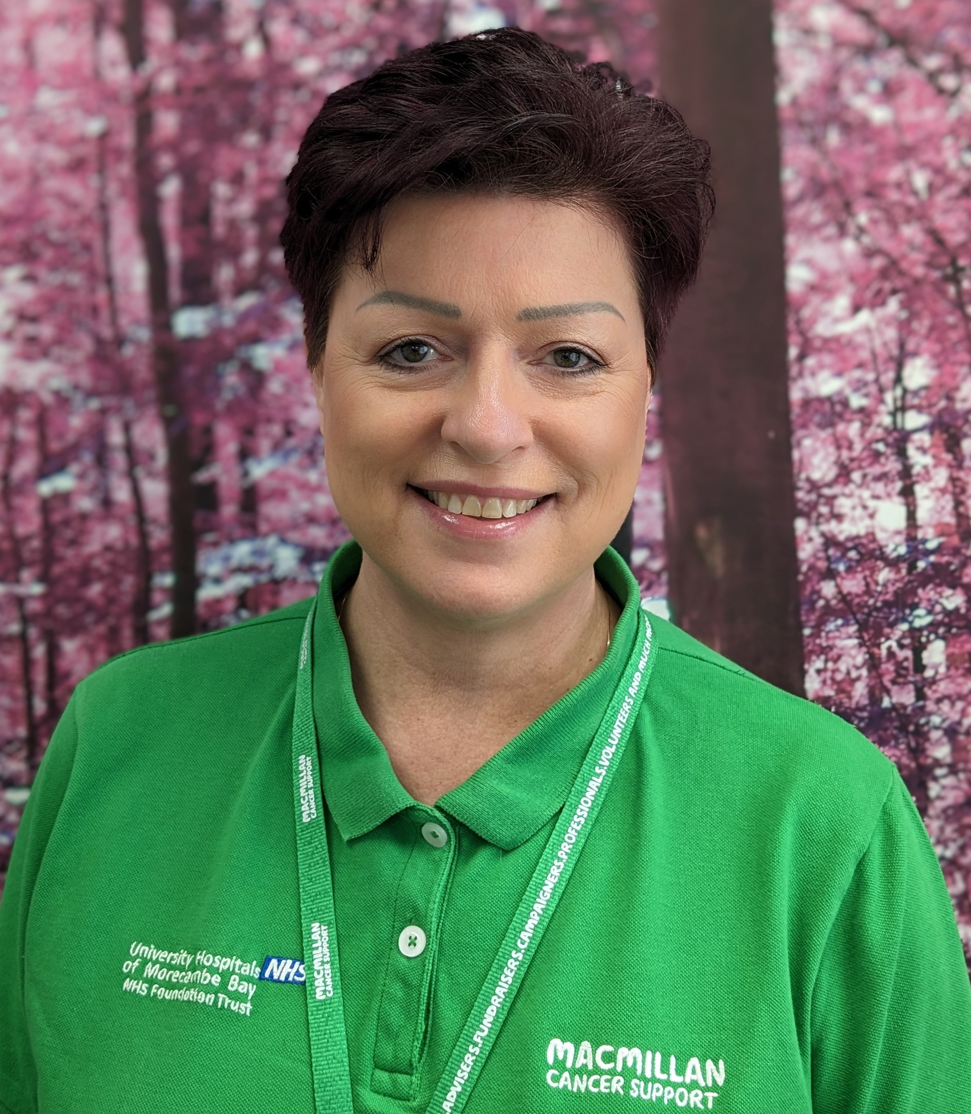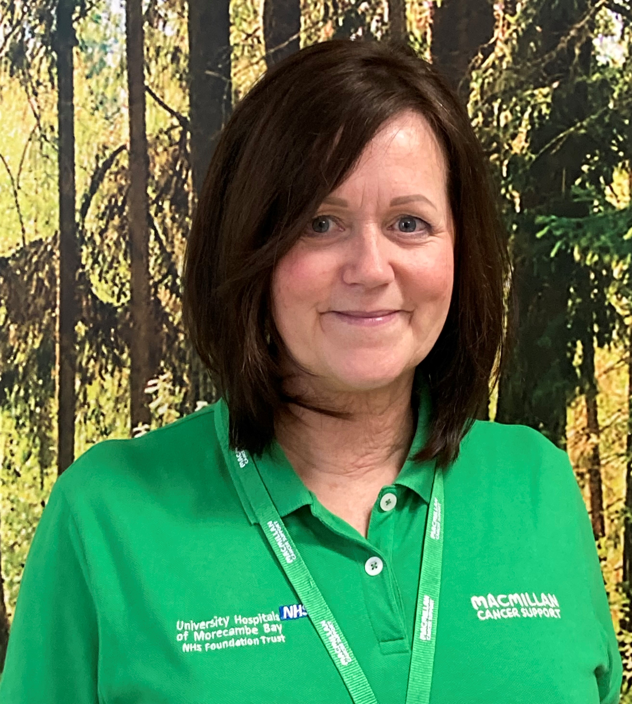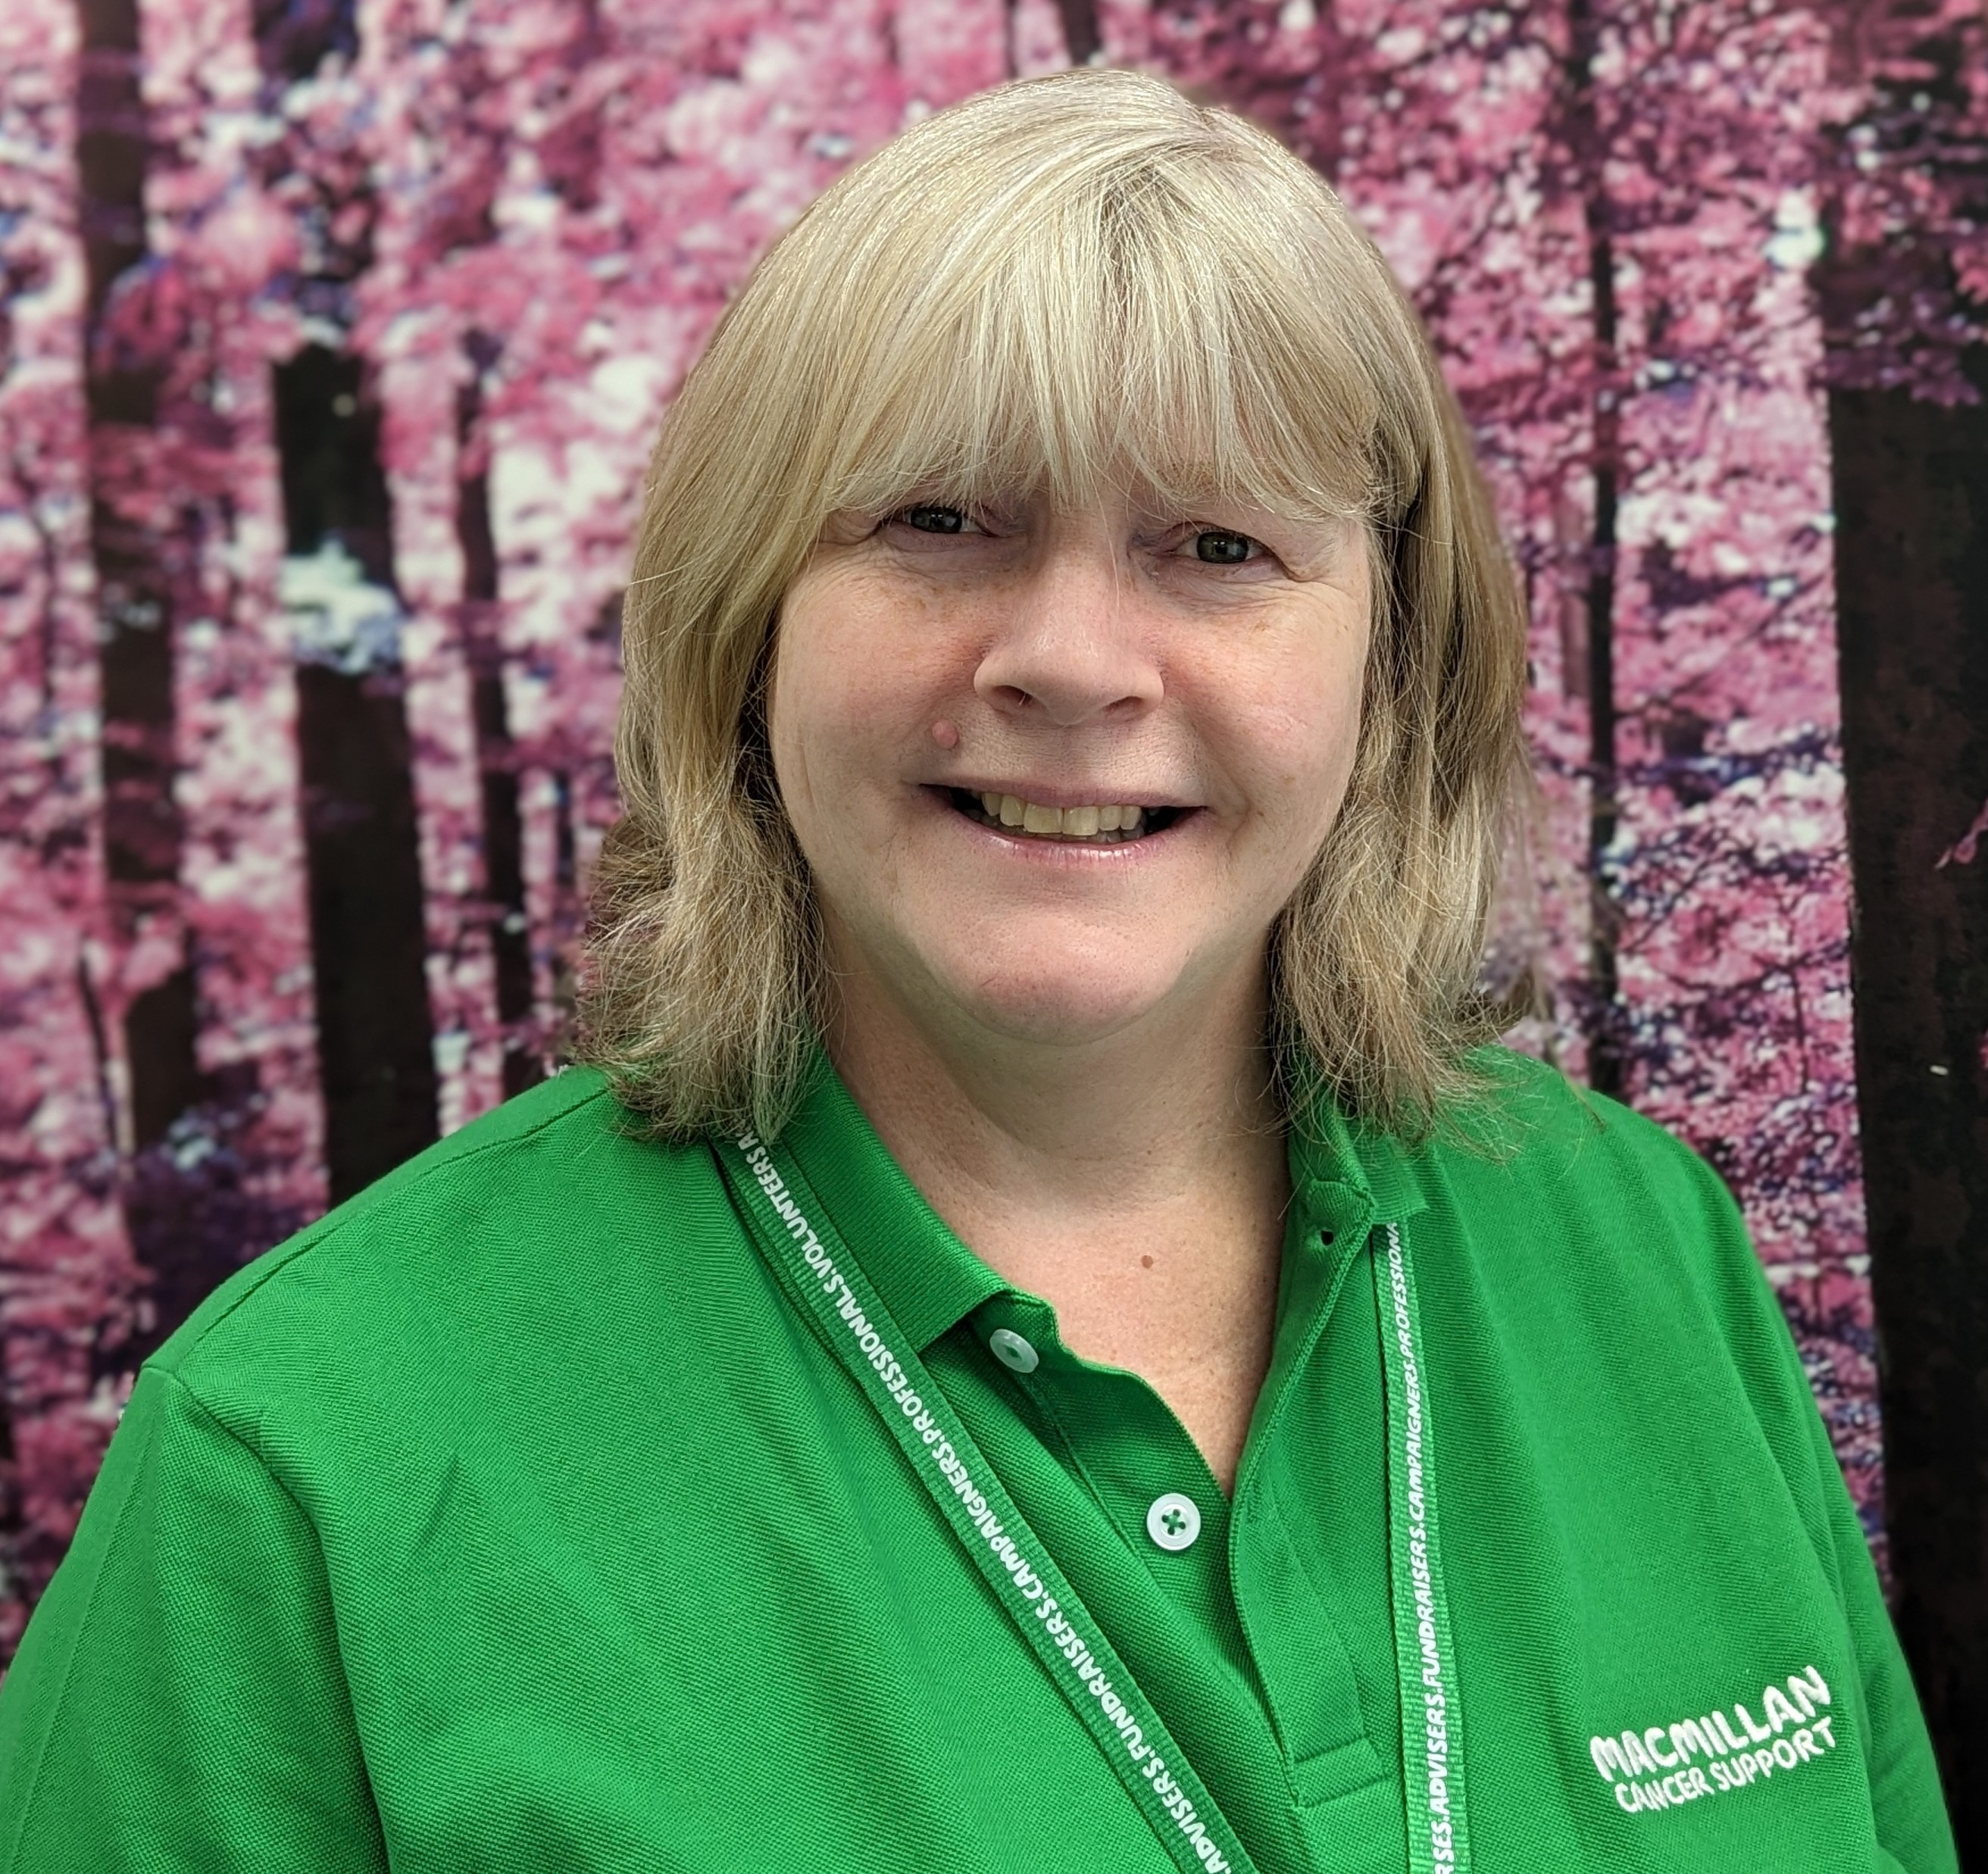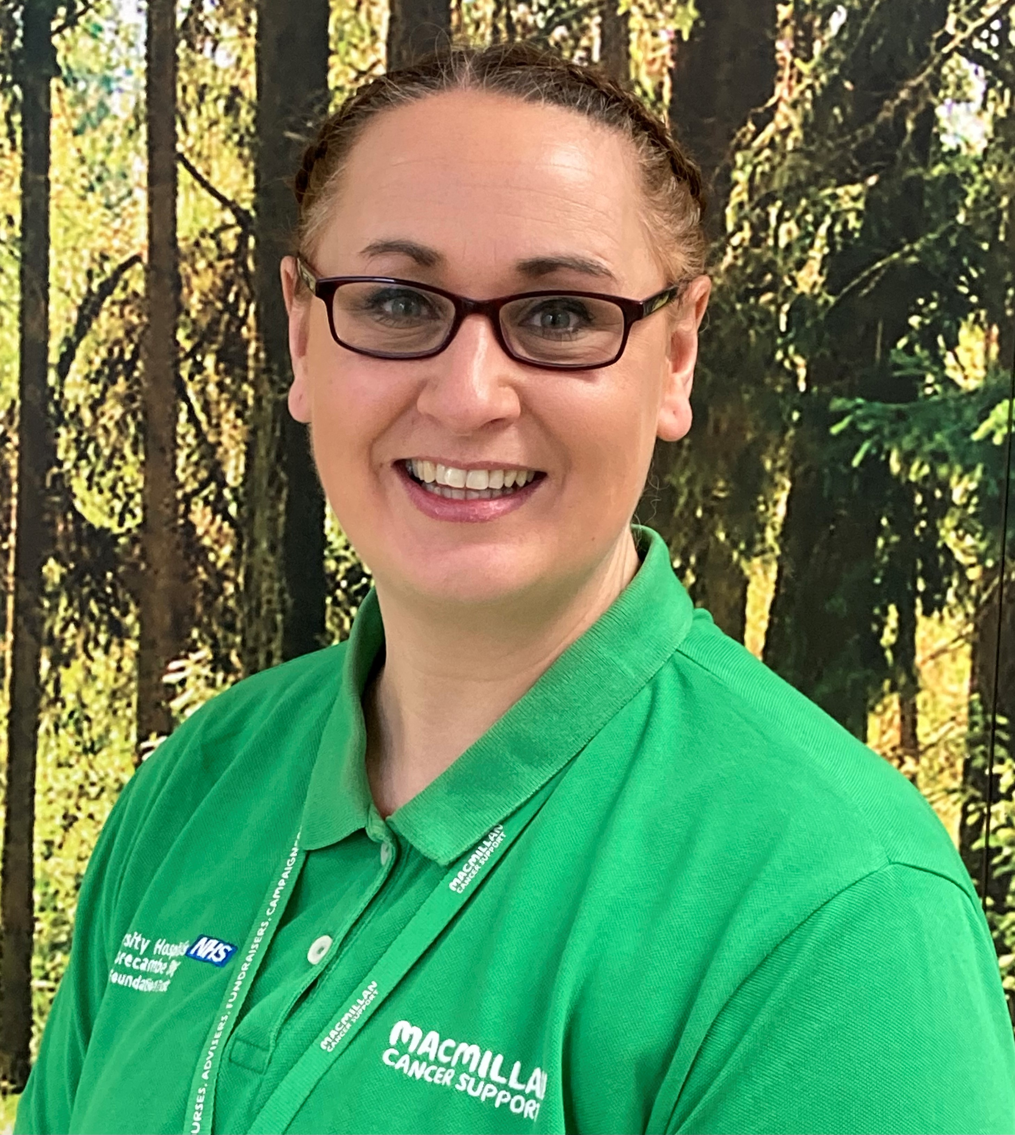

Lorraine Jones Joanne Gardner Judith Brassington Sallie Robinson
Manager Assistant Assistant Manager
We provide a non-nursing information and support service working in partnership with the hospital cancer team.
We support the people living in North Lancashire and South Cumbria.
How can we help?
- We provide a wide range of literature available in different formats and languages, including ‘easy read’.
- We are here if you would like to have a chat.
- We can signpost you to local and national services.
- We have access to counselling and emotional support services.
- We have close links with the cancer team for clinical information.
- We can support you to completing a Holistic Needs Assessment (HNA) / Care plan.
- We can support with any financial issues or concerns.
- We link with the local Citizen’s Advice Teams, for onward financial assessments, work and employment questions and concerns.
You can contact us by:
Telephone: 01524 519578 Text call: 07972 639424
Email: Macmillan.info@mbht.nhs.uk
Your call is important to us. If we are unable to take your call, please do leave a message on our confidential answer machine with your name and contact number.

Whatever you need, do ask.
No matter how cancer affects you, or how big or small your questions are, we are here to help.

The Macmillan Information and Support Centre at Furness General Hospital and The Royal Lancaster Infirmary are staffed by Macmillan professionals and supported by NHS trained volunteers.
We offer free support and information to those affected by cancer. Whether you are living with or beyond cancer, or you are a family member, friend or carer, we are here to support you.
- Our service offers the opportunity to talk to us, one-on-one, about what matters the most to you.
- We work with a range communication methods, including face-to-face, telephone, video call, or email.
- We can help you understand what financial support is available to you. We can also support you in completing Macmillan grant applications.

Drop-in Service:
- Please note that we may be busy supporting other people if you drop in; however, please help yourself to any of the information booklets.
- If you would like to book a one-to-one meeting, please contact us using the information overleaf.
Thank you.
Notes:




