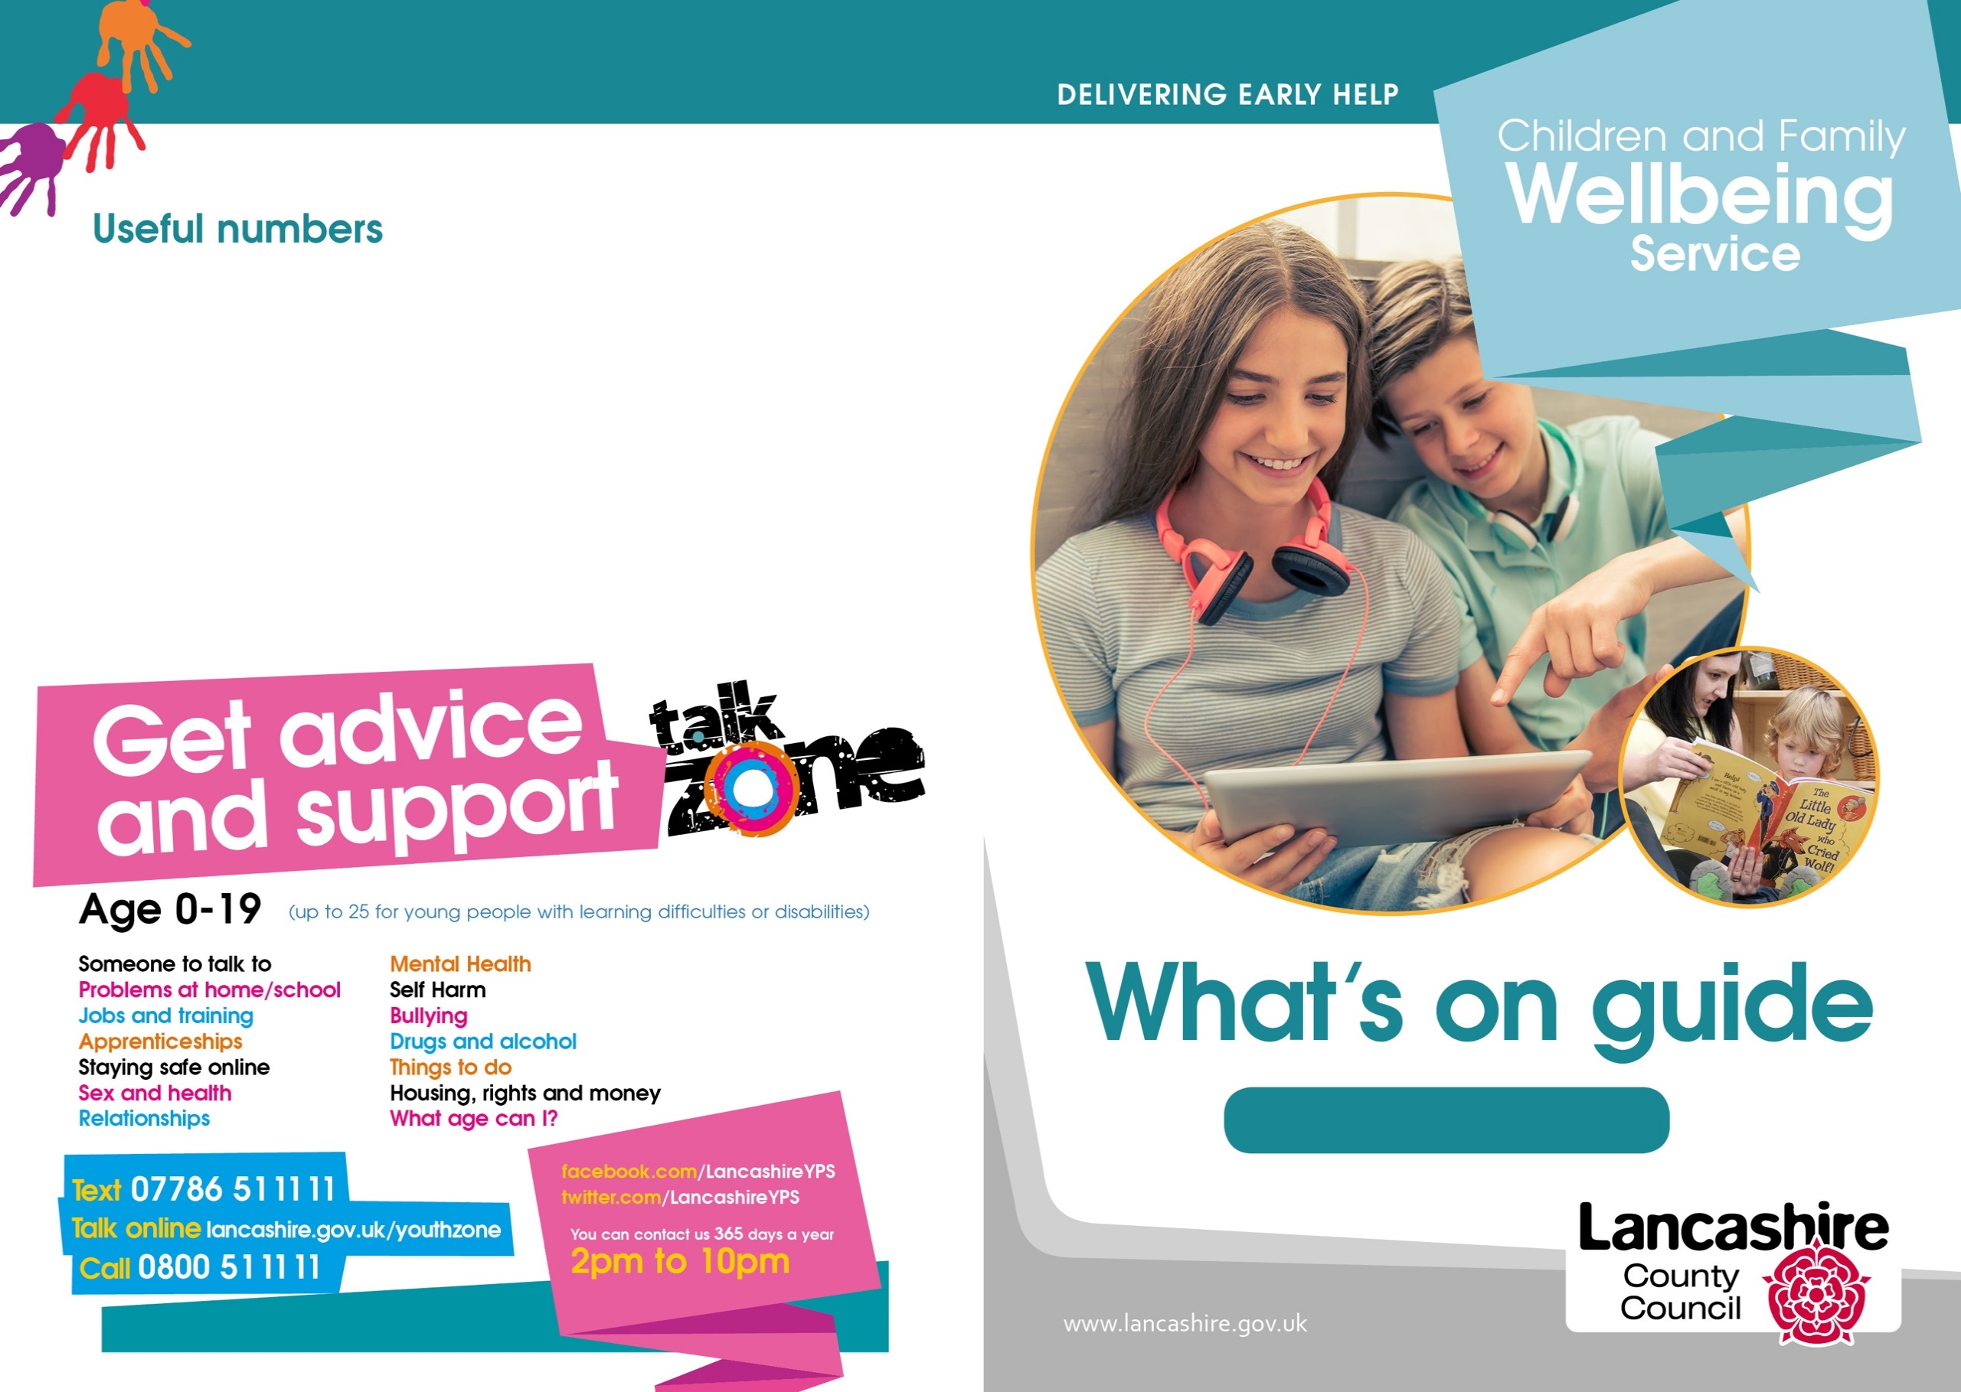

April – June 2023

**To contact our Neighbourhood Centres:**

01524 581280

**To make a self-referral for support via the Children's Services Support Hub:**

03001236720

**Lancaster District**

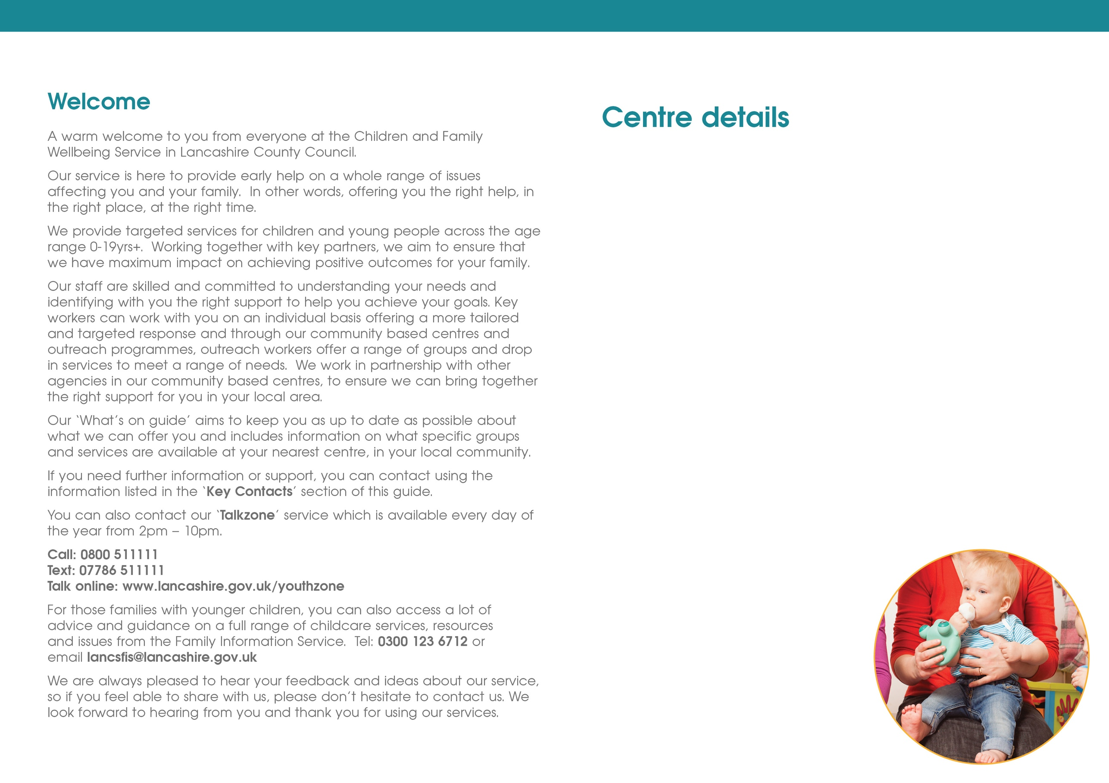

**Healthy Start vitamins**

Healthy Start vitamins contain vitamins A, C and D for your child.

Folic acid and vitamins C and D for you if you are pregnant, breastfeeding or until your baby is one year old.

Drops are for your child if they are aged from six months (unless a health visitor has advised earlier use of vitamins) until they are four years old, and mums get tablets.

You need to be in the NHS Healthy Start Scheme to obtain free Healthy Start Vitamins.

If you need more information please contact your Midwife, Health Visitor, or your nearest centre.

Centres are opened 9am – 5pm Monday to Friday to obtain drops/tablets.

**Lune Park Neighbourhood Centre**

Ryelands Park

Owen Road

Lancaster

LA1 2LN

**Poulton Neighbourhood Centre**

The Old Fire Station

Clark Street

Morecambe

LA4 5HT

**Westgate Neighbourhood Centre**

Langridge Way

Morecambe

LA4 4XF

**Neighbourhood Centres Telephone Contact details:**

**01524 581280**

**Lancaster and Morecambe**

**Family Zone**

**Online details**

Family Safeguarding is a new Children's Social Care team working in partnership with all Children's Services – please follow on

**@LancsFamilies**

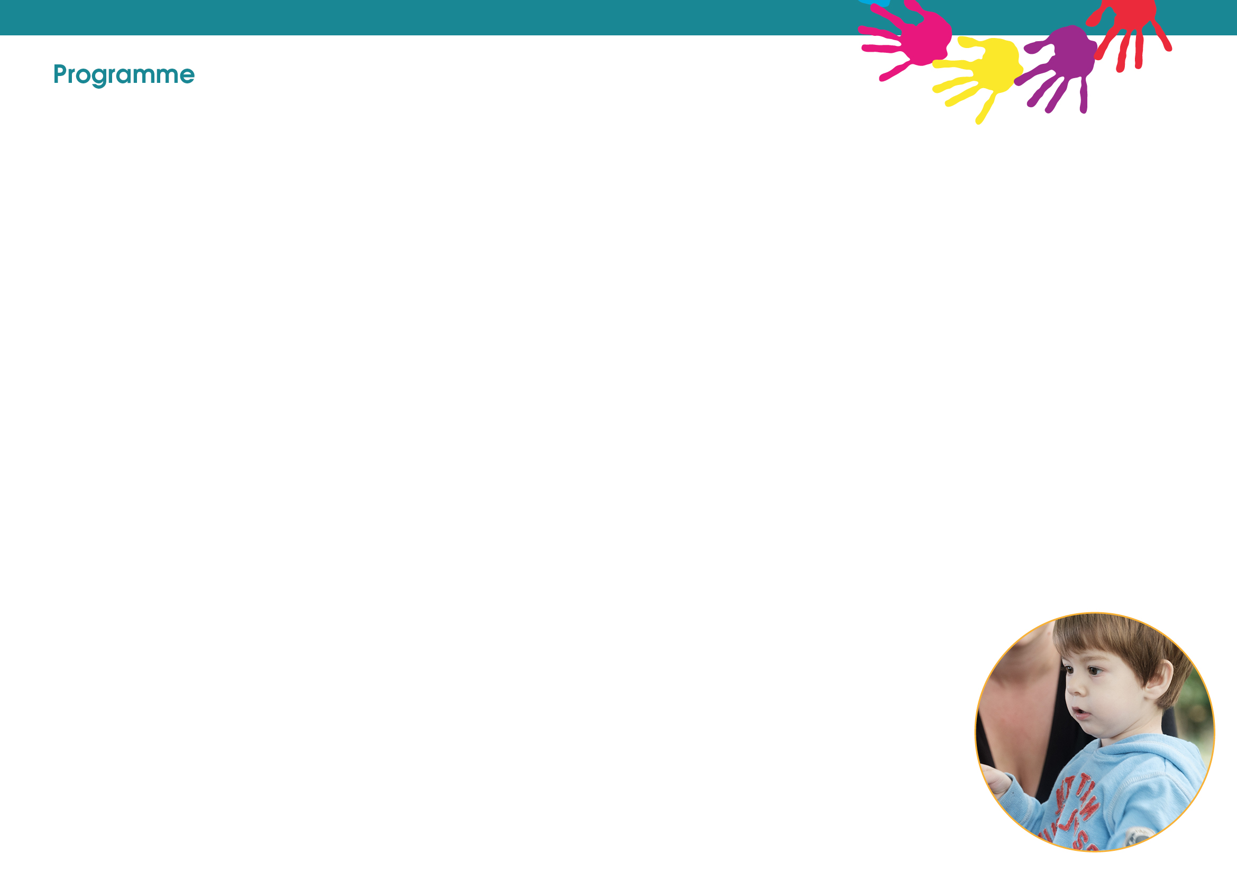

**Tuesday**

**Lune Park**

**Healthy Relationships (B)**

9.30-11.30am

**Infant Massage (B)**

10am – 11am

**Infant Massage (B)**

11am-12pm

**Chat, Play & Read**

1pm – 2.30pm

**Morecambe Library**

**Young Parents to be**

1pm -3pm

**Inside Out** (8-11 years)

3.30pm – 4.45pm

**Westgate**

**Infant Massage (B)**

10am – 11am

**(B) Bookable Session.**

**Please call the centre for more information.**

**Friday**

**Lune Park**

**Mini Move & Groove**

9.30am – 11am

**Poulton**

**FAB (Breastfeeding Support Group)**

9.30am – 11.30am

**Westgate**

**Development Matters**

9.30am – 11am

**Baby & You**

1pm-2pm

**Thursday**

**Lune Park**

**Triple P Group (B)**

9.30-11.30

**Parents to Be (B)**

5.30pm – 7.30pm

**Poulton**

**Infant Massage (B)**

1pm – 2pm

**Westgate**

**Chat, Play & Read**

9.30am – 11am

**Online Zoom**

**Triple P Group(B)**

5.30pm-7.30pm

**Wednesday**

**Lune Park**

**Development Matters**

9.30am-10.30am

**Warm Welcome**

10.30am – 11.30am

**Colourful Footsteps**

1pm– 2.30pm

**Poulton**

**Baby & You**

9.30am-10.30am

**Back to Me (B)**

9.30am – 12.30pm

**Westgate**

**Parents to Be (B)**

5.30pm-7.30pm



**Scan the QR Code to access our Facebook page.**

**Monday**

**Lune Park**

**Baby & You**

10am – 11am

**Poulton**

**Development Matters**

9.30am – 11am

**Morecambe Library**

**Move & Groove** (8-11years)

3.30pm – 4.45pm

**The Sensory Room at Poulton**



We have a Sensory Room available to use **free** of charge at Poulton Neighbourhood Centre.

Use of the Sensory Room is subjected to availability.

Bookings can be made between 09:00 and 17:00 Monday to Friday.

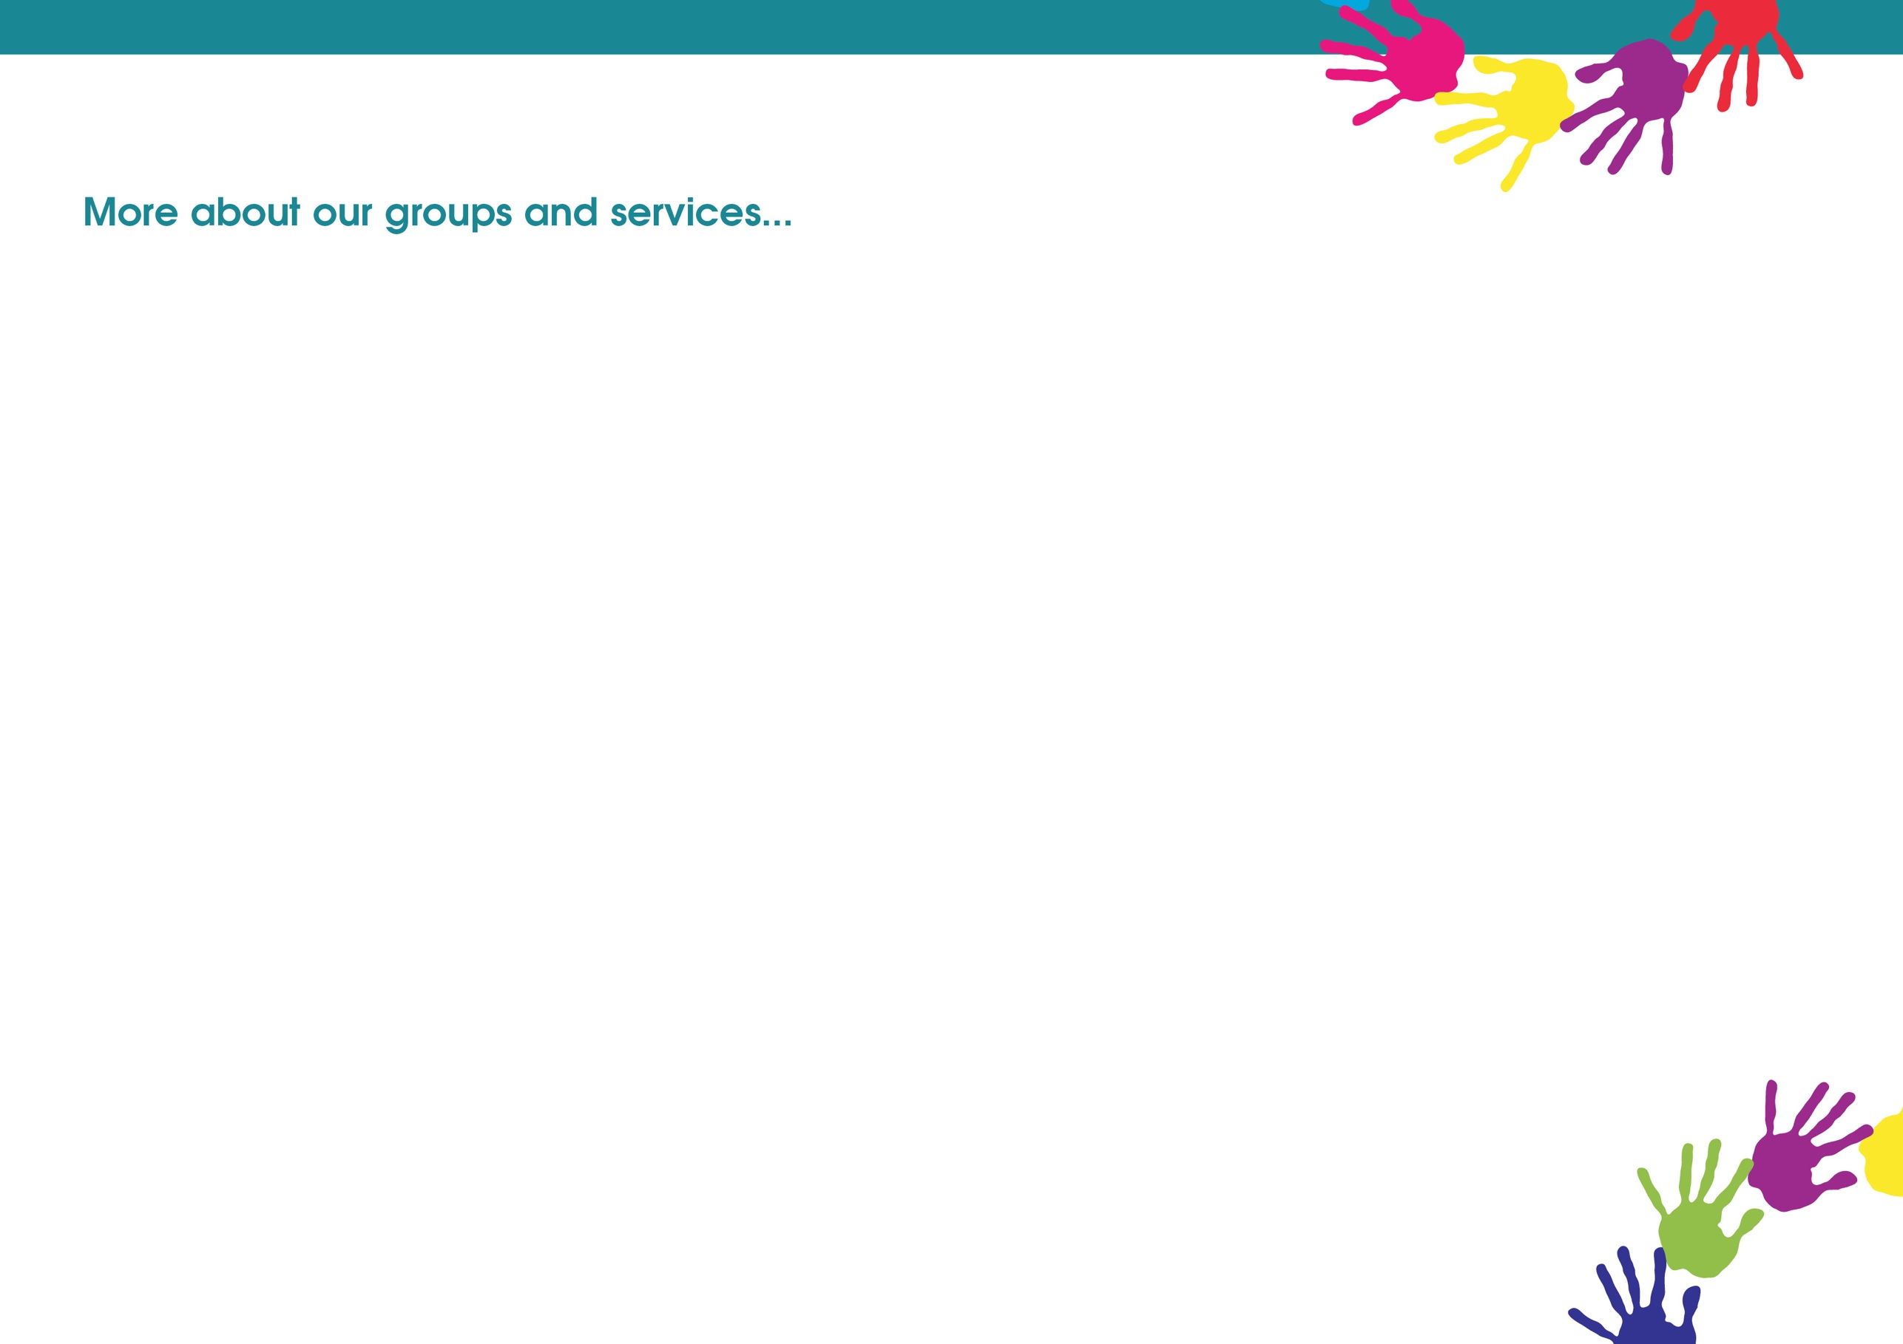

**Friday**

**Open Youth Club (12 to 19yrs or up to 25 with SEND)**

6.15pm – 8.30pm

This group is open to any young person in the local area. Safe space for young people to hang out with friends and opportunities to participate in a variety of activities.

Held at **Morecambe Library.**

Contact: Charlie Bluglass 07977273886



PYRO (LGBTQ+) (13-17yrs)

Fun, informative sessions, exploring key topics and issues affecting young people who identify as LGBTQ+. Providing an opportunity to meet other young people, make friends, socialise, and support each other.

For more information regarding date/time/venue

Contact: Nicole Cobb 07887631335

**Youth Impact Group (12 to 19yrs or up to 25 with SEND)**

3.30pm – 5.45pm

This is a small group for young people with issues such as social anxiety. This is a nurturing group to help build self-confidence and communication skills in social situations.

Held at **Morecambe Library.**

Contact: Claire Armer 07717815062

**Thursday**

**Detached Session (12 to 19yrs or up to 25 with SEND)**

6.15pm – 8.30pm

Fun and interactive activities and discussions with young people out in the communities where they live, young people will lead the focus of the work. Held alternative weeks between Morecambe and Lancaster.

Contact: Charlie Bluglass 07977273886

**Connect group**

(For Ukrainians young people 12 to 19yrs or up to 25 with SEND)

3.30pm – 6.30pm

Group is to support young people's integration into the local community.

Contact: Nicole Cobb 07887631335

**Youth Programme**

**To take part in sessions contact named worker for more details.**



**Monday**

**EASY Youth Group for those with SEND (12-25yrs)**

6.15pm – 8.30pm

A group for young people with special educational needs and disabilities. Activities include cooking, games and physical activities in a safe supportive environment.

Taking place at **Morecambe Library**.

Contact Claire Armer 07717815062

**Wednesday**

**Locality Youth Council (12 to 19yrs or up to 25 with SEND)**

6.15pm – 8.30pm

A group for young people who would like to be involved in making a difference in their local community, whilst engaging in fun and enjoyable sessions. Supporting north participation, discussing local projects and issues.

Taking place at **White Cross**.

Contact: Charlie Bluglass 07977273886

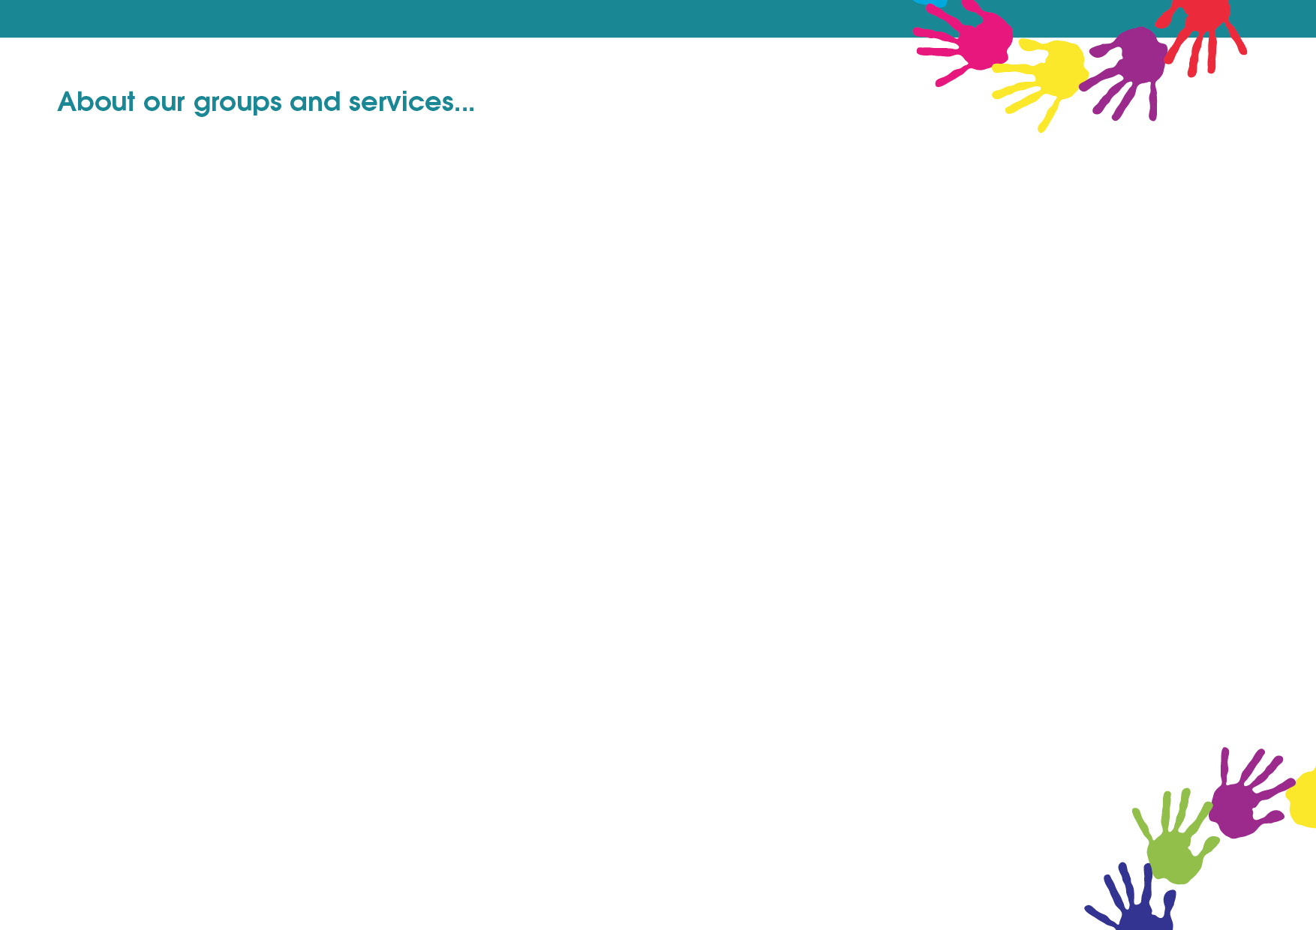

**Freedom for Children**

One to one and small group sessions for children who have suffered from domestic abuse. The programme offers activities that are child led, age appropriate and sensitively delivered to help children work through their fears, anxieties and emotions.

**Moving On Up (Year 6 and 7)**

The sessions will help children to explore feelings and emotions around transition to secondary school and build their self-esteem and confidence.

**Parenting and Family Support**

**Warm Welcome**

A warm and friendly space for people to connect with others within the community and receive information and advice if needed. Free hot drinks and snacks provided and toys available to keep your little ones entertained too.

**Back To Me**

This is a three-week course which allows you to focus on yourself, improves your wellbeing, and develop strategies to help you feel more confident to deal with life stressors.

**Healthy Relationships**

Whether you are together or separated, arguments between parents are a normal part of relationships. However, there is new evidence that shows they could have an impact on your child when they are frequent, intense, or unresolved. HealthyRelationships is a course of 6 weekly sessions which aims to empower you to understand conflict in your relationship and see how to resolve the issues yourselves.

**Triple P Teen**

Evidenced based programme for parents with teenagers up to 16 years. The course is delivered across 8 sessions focused on raising responsible and competent teenagers.

**Triple P Group**

Evidenced based parenting programme for parents of children aged 2-11 years old. The course is delivered across 8 sessions focused on Positive Parenting and raising confident, competent, and resilient children.

**Triple P Teen**

Evidenced based programme for parents with teenagers up to 16 years. The course is delivered across 8 sessions focused on raising responsible and competent teenagers.

**Triple P Stepping Stones**

Evidence based programme for parents who have children with a disability or other additional needs up to 12 years old. The course is delivered across 9 sessions focused on positive parenting for children with a disability and helping your child reach their potential.

**Freedom Programme**

Relaxed, informal group for women who have experienced domestic abuse, from a partner or family members and would like to be able to recognise abusive behaviours and understand what makes a healthy relationship.

**Early Childhood Services (0-5)**

**Parents To Be**

Preparing for parenthood through sharing key messages on Safer sleep, ICON, home safety, caring for a newborn's needs and the importance of communication.

**Young Parents to Be**

Antenatal group for parents aged 20 and under, delivered alongside the Specialist midwife for Teenage Pregnancy.

**Infant Massage – birth to crawling**

A six-week programme which involves gently and rhythmically stroking your baby's body to promote bonding and interaction.

**Baby and You**

This group encourages positive play and interaction between you and your baby with key messages about how to care for your baby through their early stages of development.

**Development Matters**

Stimulating and challenging activities across all ages from 0-5yrs based on child-initiated play guided by the Early Years Foundation Stage Development Matters.

**Chat, Play and Read**

The sessions will provide opportunities to read and share books together, exploring the fun, rhythms and excitement of words and stories to support your child’s speech and language development.

**Mini Move and Groove**

A range of physical health and wellbeing activities for early years children to help guide them on their first steps to living well and boosting their physical and motor development.

**The Developing Child (5-11)**

**Inside Out (8-11 years - Key Stage 2)**

Emotional health and wellbeing targeted group. A range of strategies and creative, physical activities to encourage positive play, build self-confidence and manage anxious feelings.

**Move and Groove (5-8 years and 8-11 years)**

A safe, sensitive and nurturing space for children to meet and have fun together, promoting physical activity and healthy lifestyles.

**Colourful Footsteps**

A group for children with physical, learning, behavioural or emotional difficulties. We offer an inclusive environment, positive social interactions and learning and development opportunities.

