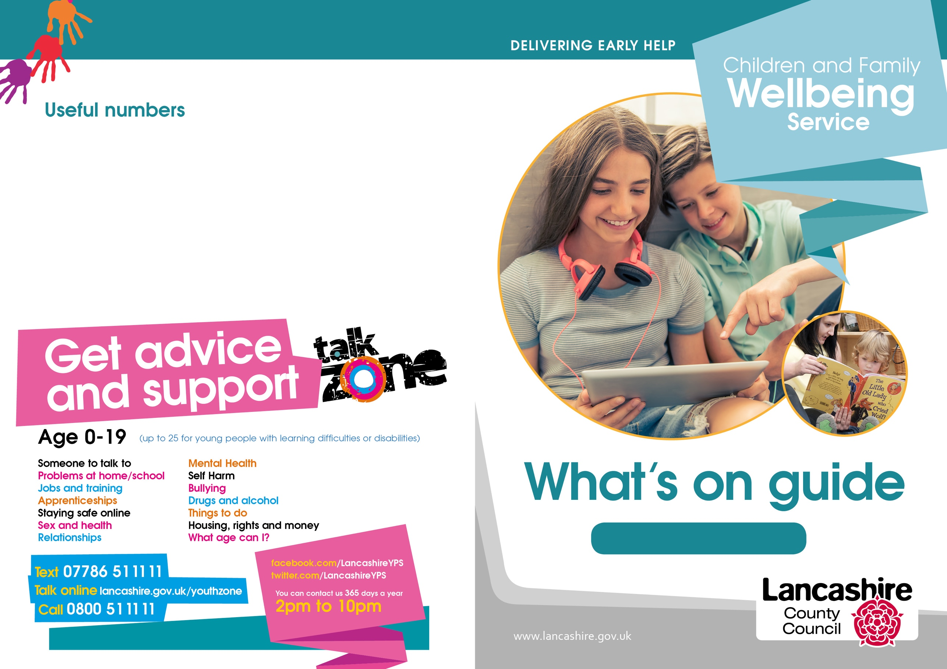89

August 2022

**Lune Park Neighbourhood Centre:**

01524 581280

**Westgate Neighbourhood Centre:**

01524 586509

**Poulton Neighbourhood Centre:**

01524 581281

**Lancaster District**

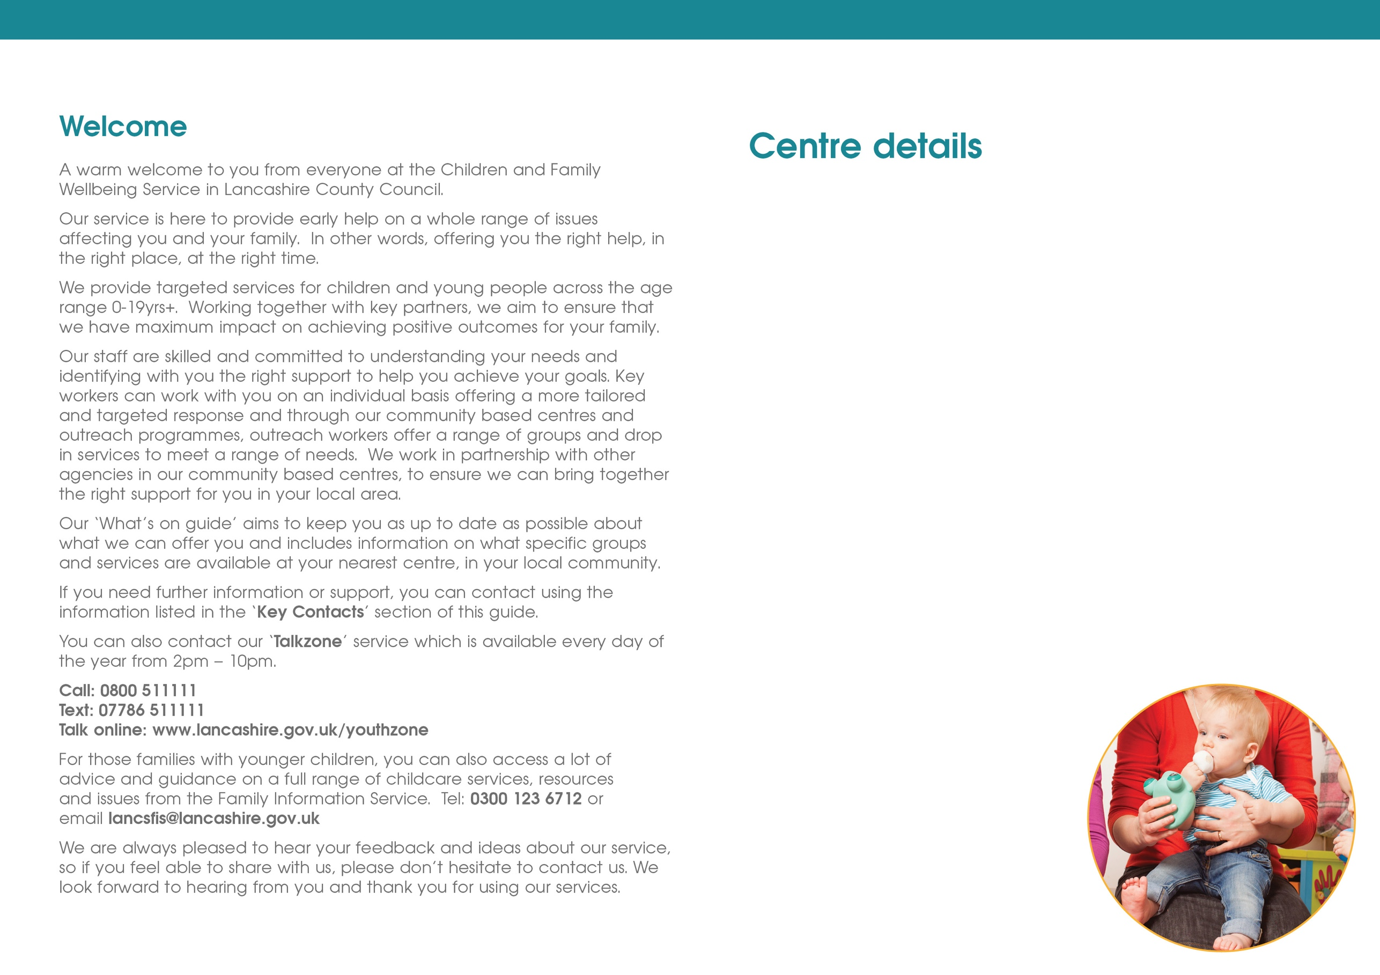

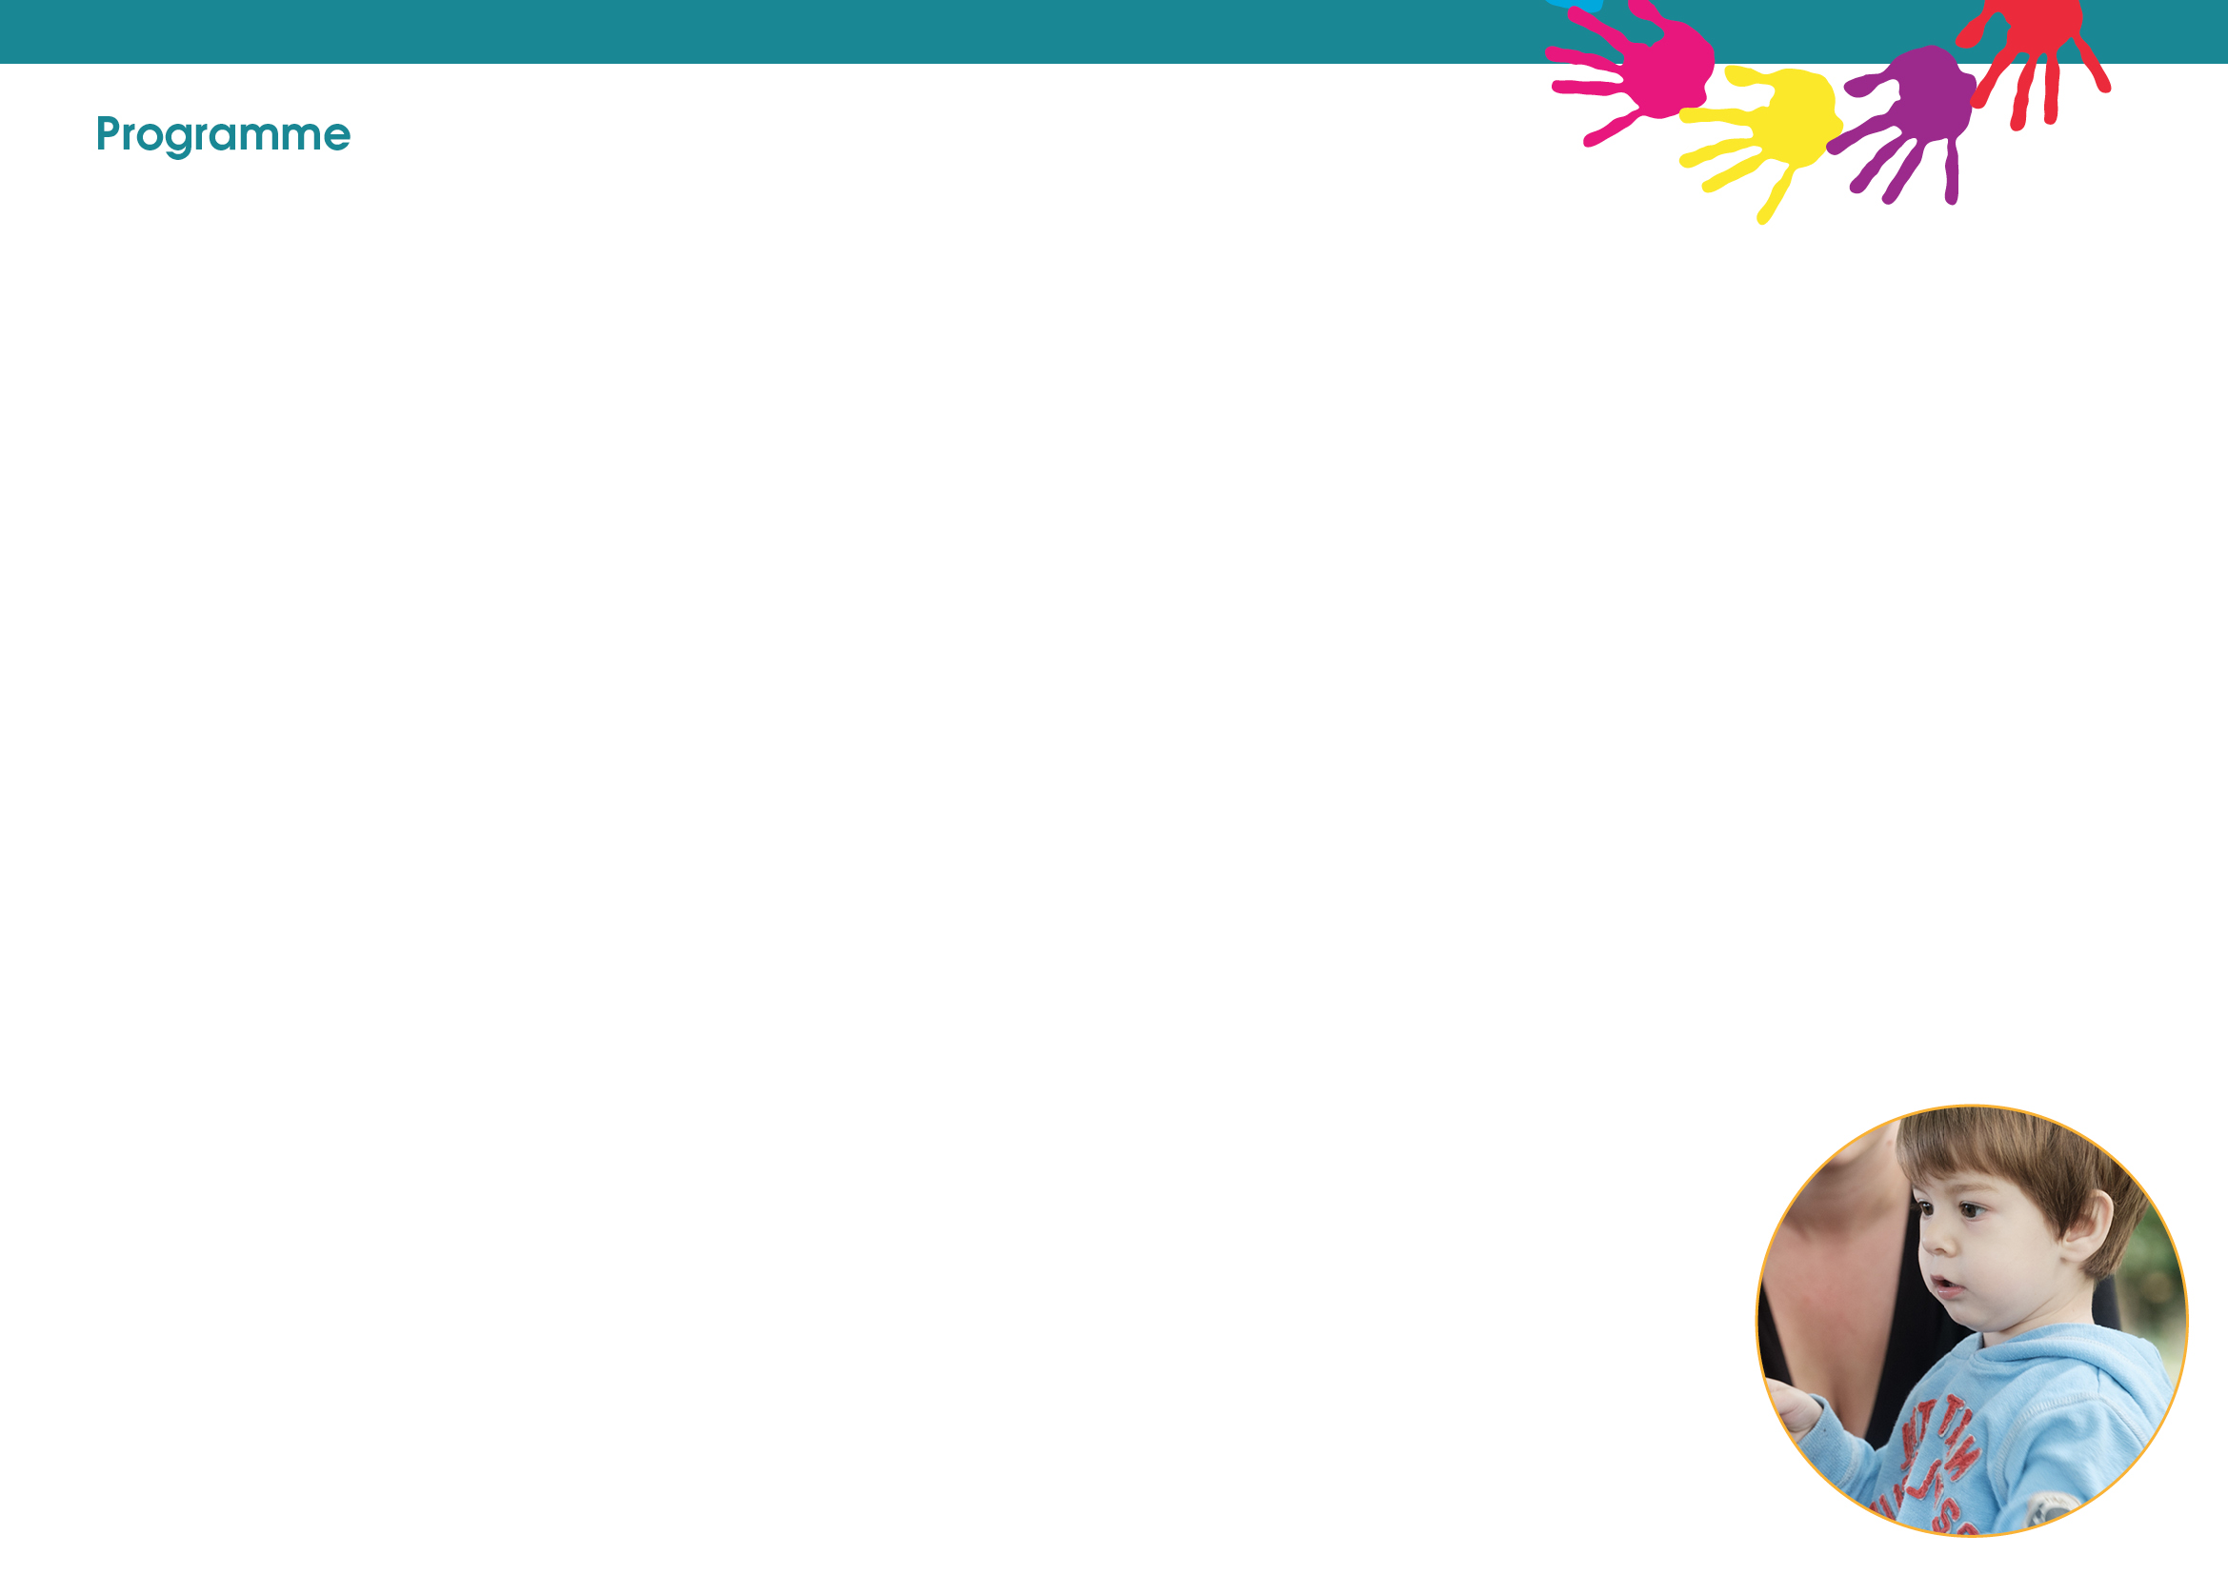

**Lune Park Neighbourhood Centre**

Ryelands Park

Owen Road

Lancaster

LA1 2LN

01524 581280

**Poulton Neighbourhood Centre**

The Old Fire Station

Clark Street

Morecambe

LA4 5HT

01524 581281

**Westgate Neighbourhood Centre**

Langridge Way

Morecambe

LA4 4XF

01524 586509

**Online details**

Family Safeguarding is a new Children's Social Care team working in partnership with all Children's Services – please follow on Twitter **@LancsFamilies**

Facebook: **Lancaster and Morecambe Family Zone**

**\*Open Tuesdays, Wednesdays, and Fridays between 10am – 12 noon for Vitamin D drops.**

**\*Open Mondays and Thursdays between 10am – 12 noon for Vitamin D drops.**

**\*Open Wednesdays, and Thursdays between 10am – 12 noon for Vitamin D drops.**

**Friday**

**Westgate**

**Development Matters**

9.30am – 10.30am

**Poulton**

**Transitions**

11am – 12noon

**Thursday**

**Lune Park**

**Baby & You**

1pm – 2pm

**Healthy Relationships**

1pm – 2pm

**Transitions**

3pm – 4pm

**Westgate**

**Chat, Play & Read**

9.30am – 10.30am

**Poulton**

**Infant Massage**

10am – 11am

**Wednesday**

**Lune Park**

**Development Matters**

10am – 11am

**Colourful Footsteps**

1.30– 2.30pm

**Inside Out** (8 -11 years)

3.30pm – 5pm

**Westgate**

**Baby & You**

1pm – 2pm

**Monday**

**Poulton**

**Development Matters**

9.30am – 10.30am

**Westgate**

**Transitions**

3pm – 4pm

**Morecambe Library**

**Inside Out** (8 – 11 years)

3,30pm – 5pm

**The Sensory Room at Poulton**



We have a Sensory Room available to use **free** of charge at Poulton Neighbourhood Centre.

Use of the Sensory Room is subjected to availability.

Bookings can be made between 09:00 and 17:00 Monday to Friday.

Book via 01524 581281.

**Tuesday**

**Lune Park**

**Infant Massage**

10am – 11am

**Infant Massage**

11am-12am

**Chat, Play & Read**

1pm – 2pm

**Westgate**

**Infant Massage**

10am – 11am

**Poulton**

**Baby & You**

10am - 11am

**Morecambe Library**

**Young Parents to be**

1pm -3pm

**Inside Out** (8-11 years)

3.30pm – 5pm

**Online Zoom**

**Parents to Be**

3.30pm – 4.30pm

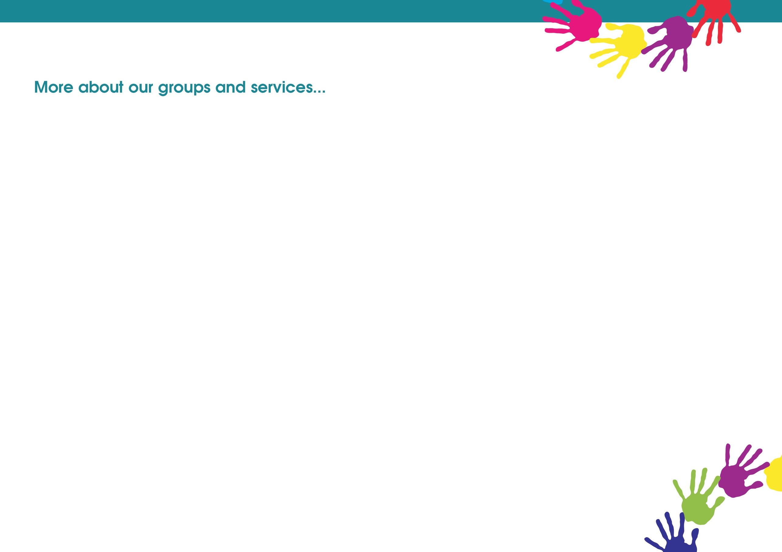­

**Friday**

**Open Youth Club (12 to 19yrs or up to 25 with SEND)**

6.15pm – 8.30pm

This group is open to any young person in the local area. Safe space for young people to hang out with friends and opportunities to participate in a variety of activities. Held at **Morecambe Library.**

Contact: Charlie Bluglass 07977273886



PYRO (LGBTQ+) (13-17yrs)

Fun, informative sessions, exploring key topics and issues affecting young people who identify as LGBTQ+. Providing an opportunity to meet other young people, make friends, socialise, and support each other.

For more information regarding date/time/venue

Contact: Nicole Cobb 07887631335

**Thursday**

**Thursday Youth Impact (12 to 19yrs or up to 25 with SEND)**

3.30pm – 5.30pm

This is a small group for young people with issues such as social anxiety. This is a nurturing group to help build self-confidence and communication skills in social situations. Held at **Morecambe Library.**

Contact: Claire Armer 07717815062

**Detached Session (12 to 19yrs or up to 25 with SEND)**

6.15pm – 8.30pm

Fun and interactive activities and discussions with young people out in the communities where they live, young people will lead the focus of the work. Held in the Morecambe area.

Contact: Charlie Bluglass 07977273886

**Detached Session (12 to 19yrs or up to 25 with SEND)**

6.15pm – 8.30pm

Fun and interactive activities and discussions with young people out in the communities where they live, young people will lead the focus of the work. Held in the Lancaster area.

Contact: [chris.mcqueen@lancashire.gov.uk](mailto:chris.mcqueen@lancashire.gov.uk)

**Youth Programme**

**To take part in sessions contact named worker for more details.**



**Monday**

**EASY Youth Group for those with SEND (12-19yrs)**

6.15pm – 8.30pm

A group for young people with special educational needs and disabilities. Activities include cooking, games and physical activities in a safe supportive environment. Taking place at **Morecambe Library**.

Contact Claire Armer 07717815062

**Wednesday**

**Locality Youth Council (12 to 19yrs or up to 25 with SEND)**

6.15pm – 8.30pm

A group for young people who would like to be involved in making a difference in their local community, whilst engaging in fun and enjoyable sessions. Supporting north participation, discussing local projects and issues. Taking place at **Morecambe Library**.

Contact: Charlie Bluglass 07977273886

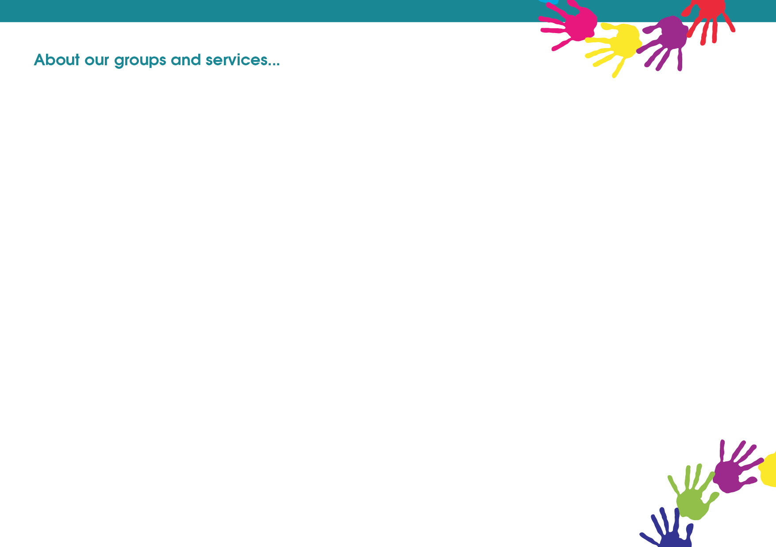

**The Developing Child (5-11)**

**Inside Out** **(8-11 years - Key Stage 2)**

This groups helps to support children who may be struggling to express and manage their emotions or are presenting anxious behaviours and low self-confidence.

*In the sessions children will be able to:*

• Explore wishes and feelings and understand worries

• Look at a range of strategies to help manage strong emotions

• Take part in creative and physical activities to encourage positive interaction with their peers.

• Build confidence and social skills

• Meet new people and make new friends

**Colourful Footsteps**

We also provide sessions in our centres for children with physical, learning, behavioural or emotional difficulties. We offer an inclusive environment, with opportunities for learning, development, and support. Parents and carers can meet and make new friends and share experiences. There will also be information to hand about professional support so you can be signposted to other agencies, groups, and services.

**Development Matters**

*The sessions* provide:

• Stimulating and challenging activities across all ages from 0-5yrs based on child-initiated play both indoors and guided by the Early Years Foundation Stage Development Matters.

• Information about how to support your child's learning and development through songs and play.

• Opportunities for physical play in a safe environment.

• A safe and secure environment for your child to develop their confidence, social and emotional skills and make friends.

• The chance to meet with other families and make new relationships.

**Chat, Play and Read**

*The sessions will:*

• Provide opportunities to read and share books together, exploring the fun, rhythms and excitement of words and stories.

• Support your child’s listening skills by reading aloud to them and support you to do the same.

• Encourage children to use language in their play, describing, predicating, sharing ideas, and explaining.

• Support you as a parent with ideas of how you can support your child’s speech and language development.

• Help children make sense of the world around them.

**Early Childhood Services (0-5)**

**Parents To Be**

*The sessions will help you to prepare for parenthood sharing some key messages such as****:***

• Safer sleep for your baby

• Support on feeding your baby

• How to ensure your home is safe and ready for your baby

• Support with how to care for your newborn’s needs

• The importance of communication and talking to your baby and how this supports the developing brain

• Strategies for coping with a crying baby including ICON message

• Early Play

• Smoking and ‘Smoke Free Homes’

**Young Parents to Be**

A group for parents aged 20 years and under. Antenatal care and information to help you make informed choices about birth as well as key messages about infant feeding, safer sleep, play, communication and taking care of your new baby.



**Infant Massage – birth to crawling**

*The sessions will:*

• Help you to feel the relaxing effect of giving your baby a massage

• Strengthen the bonding process

• Build your confidence in handling your baby

• Supporting your baby’s development in helping their physical needs if there is any tummy trouble, problems with bowel movement or trapped wind.

• Provide opportunities to meet other parent/carers, develop networks and peer support.

• Provide information about brain development, digestion, and nurturing relationships.

**Baby and You**

*The sessions will:*

• Provide information about your child’s ages and stages of development, particularly the growing brain and your crucial role in supporting this.

• Provide you with opportunities to play together and encourage positive play and interaction between you and your baby.

readiness.

• Help you with any issues around bonding, connection & communication between you and your baby.

• Bring you together with other parents to prevent you from feeling socially isolated which is often a reality for new parents.

**Healthy Relationships – strengthening families**

All families have arguments, it is part of how we negotiate and understand each other. This is constructive and children learn from seeing how arguments are resolved. However, when arguments become frequent, intense, and poorly resolved, children suffer from being exposed to it. This course aims to work in a solution focused way, enabling and empowering you as a couple to understand your conflict and see how to resolve the issues yourselves, rather than relying on a practitioner for solutions.

*The course covers:*

• The effects of conflict on parents and children, and the causes of conflict

• How are existing vulnerabilities can make us more susceptible to conflict

• Constructive and destructive communication

• Thought feelings and behaviours

• The feelings wheel, problems, and issues

• Better communication expectations and reality, goal setting.

**Parenting and Family Support**

**Triple P**

'Triple P' which stands for ‘Positive Parenting Programme’ is an evidence based parenting course. It doesn’t tell you how to be a parent. It’s more like a toolbox of ideas where you choose the strategies you need. It is delivered through group discussions, parent workbooks and homework.

**Group Triple P**

For parents of children aged 2-10 years old.

*The course covers:*

• Positive Parenting – using assertive discipline, having reasonable expectations, looking after yourself as a parent.

• Raising confident, competent children -showing respect for others, being considerate, having good communication and social skills, having healthy self-esteem, being a good problem solver and becoming independent.

• Raising resilient children- recognising and accepting feelings, expressing things appropriately, building a positive outlook, developing coping skills, dealing with negative feelings, dealing with stressful life events.

**Are you in an abusive relationship or have you been affected by domestic abuse?**

**Freedom**

The Freedom Programme is a relaxed, informal group for women who have experienced domestic abuse, from a partner or family members and would like to be able to recognise abusive behaviours and understand what makes a healthy relationship.

*The sessions:*

• Examine the roles played by attitudes and beliefs on the actions of abusive men and the responses of victims and survivors.

• Help victims and survivors make sense of and understand what has happened to them, instead of the whole experience just feeling like a horrible mess.

• Describe how children are affected by being exposed to this kind of abuse and very importantly how their lives are improved when the abuse is removed.



Contact Caroline North – Caroline.north@lancashire.gov.uk or call 01524 581281 or 07766367505for more information about the Freedom Programmes.

**Teen Triple P**

For Parents with teenagers up to 16 years.

The course covers:

• Raising responsible teenagers – taking part in family decision making, being respectful and considerate, getting involved in family activities, developing a healthy lifestyle, being reliable, being assertive.

• Raising competent teenagers, developing self-discipline, establishing good routines, getting involved in school activities, being a good problem solver following school rules, having supportive friends

**Stepping Stones Triple P**

For parents who have children with a disability or other additional needs up to 12 years old.

*The course covers:*

• Positive parenting for children with a disability – creating a positive learning environment, using assertive discipline, having reasonable expectations, looking after yourself as a parent, adapting to having a child with a disability.

• Helping your child reach their potential - promoting your child’s development by teaching them new skills and behaviours; this explores, choosing a skill to teach, breaking skills into steps, choosing rewards, deciding on where, strategies and keeping track and reviewing.