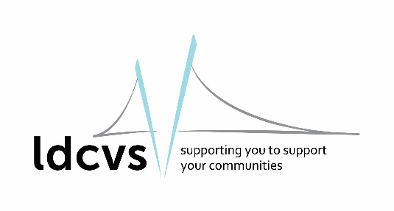
Equal Opportunities Monitoring
Post applied for: Click or tap here to enter text.
Date of application: Click or tap to enter a date.

This form will not be seen by the interviewing panel prior to interview and is not used in any decision making. You do not have to complete this form but doing so enables us to monitor the effectiveness of our Equal Opportunities Policy.
We recognise the benefits of a diverse workforce. We are committed to treating all employees with dignity and respect regardless of race, ethnic background, nationality, colour, gender, trans-gender status, pregnancy, disability, age, sexual orientation, religion or belief.
We therefore welcome applications from all segments of the community. If you are disabled, please use the space provided on the application form to identify any reasonable adjustments you may need for the interview or role you have applied for.

What is your gender? Choose an item.

What is your age between? Choose an item.

What is your sexual orientation? Choose an item.

What is your religious or belief system? Choose an item.

Do you consider yourself to have a disability? Choose an item.

What is your ethnicity?
White |  | Black, African, Caribbean or  black British
British (English, Scottish, Welsh, Northern Irish) | ☐ | Caribbean | ☐
Irish | ☐ | African | ☐
Any other white background | ☐ | Any other black, African or  Caribbean background | ☐
Asian or Asian British |  | Mixed or multiple ethnic groups
Indian | ☐ | White and black Caribbean | ☐
Pakistani | ☐ | White and black African | ☐
Bangladeshi | ☐ | White and Asian | ☐
Chinese | ☐ | Any other mixed background | ☐
Any other Asian background | ☐
Other ethnic group |  | Do not wish to declare | ☐
Arab | ☐
Any other ethic group | ☐

